DRAGON PROTOCOL

M.L.A.B

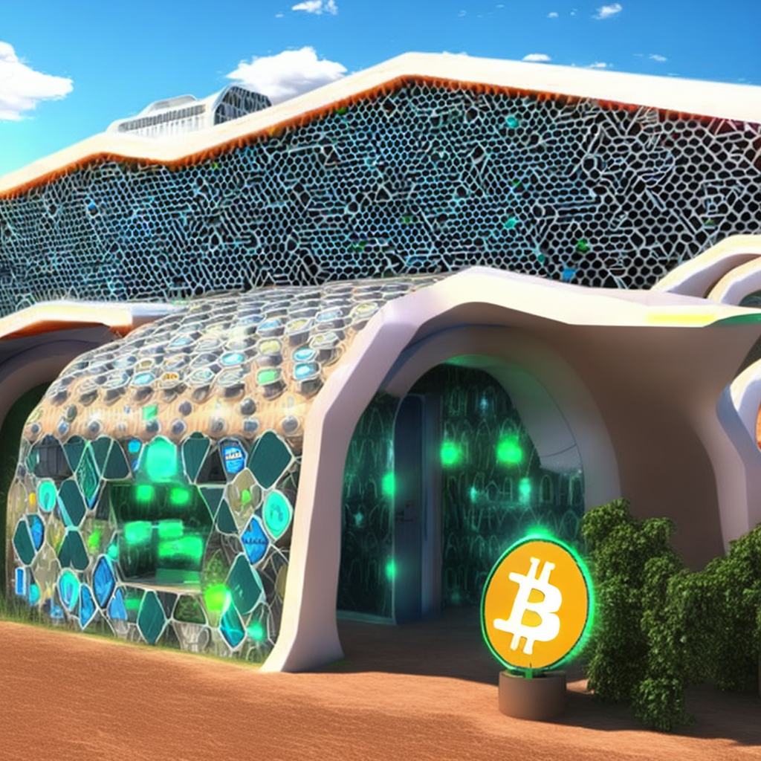

Copyright © 2023 M.L.A.B.

Attribution-ShareAlike 4.0 International (CC BY-SA 4.0).

ISBN:

Base64 Encoded Attribution Hash:  
Q29weXJpZ2h0IMKpIDIwMjMgTS5MLkEuQgoKQXR0cmlidXRpb24tU2hhcmVBbGlrZSA0LjAgSW50

ZXJuYXRpb25hbCAoQ0MgQlktU0EgNC4wKS4KCklTQk46IDEyMyA0NTYgNzg5IDEwIDExIDEyCg==

DEDICATION

This book is dedicated to the children of the future, who will inherit a world shaped by the technology we create today. May the innovations explored in these pages help to build a brighter, more secure, and more equitable future for all. It is our hope that this book will serve as a guide and a source of inspiration for the next generation of thinkers and builders.

CONTENTS

|  |  |  |
| --- | --- | --- |
|  | ACKNOWLEDGMENTS | i |
| 1 | ADAPTIVE GOVERNANCE | Pg # |
| 2 | PROGRAMMABLE ENERGY | Pg # |
| 3 | ARCHITECTING ALCHEMY | Pg # |
| 4 | UNCENSORED | Pg # |
| 5 | THE BRIDGE | Pg # |
| 6 | Chapter Name | Pg # |
| 7 | Chapter Name | Pg # |
| 8 | Chapter Name | Pg # |
| 9 | Chapter Name | Pg # |
|  |  |  |

ACKNOWLEDGMENTS

I would like to start by thanking the team at OpenAI for their work on ChatGPT. Their language processing technology was integral to the editing process for this book. I also want to express my gratitude to the team at StabilityAI and CreativeML for their help with the stable diffusion software, which was used to generate the artwork in this book. A special thanks goes to the team at CreativeML Open RAIL-M for providing the licensing and support that made it possible for us to use this software.

I also want to thank my family for their love and support throughout the writing and publishing process. Without their encouragement and understanding, this book would not have been possible.

INTRODUCTION

In the beginning, the world was ruled by centralized institutions, controlled by a select few. But the people yearned for freedom, for a system that would empower them and give them autonomy. And from this desire, the Dragon Protocol was born. The Dragon, a symbol of power and fearlessness, represents the true spirit of decentralization, a network that can't be controlled or manipulated by any single entity. The dragon symbolizes self-reliance, security, intelligence and independence, all the characteristics that make the Dragon Protocol the future of governance and societal infrastructures. The Dragon Protocol is more than just a technology, it is a movement, a manifestation of the desire for true freedom and autonomy. Welcome to Dragon Protocol, where a plan for a more positive future using available and emerging technologies and methodologies is presented. The objective is to facilitate self-determination among individuals by dismantling conventional systems of authority, by adhering to the foundational values of honesty, distributed power, openness, and security. The implementation of these principles can be extrapolated to or synchronized with various existing frameworks across multiple sectors including finance, governance, international affairs, education, mass media, and public administration, thus promoting an equitable, transparent, and enduring social structure.

In this rapidly developing ecosystem of interoperable decentralized and distributed systems, individuals can reclaim control of their digital identities and participate in self-amending protocols with elements of direct and delegated democracy, supported by open-source principles, fostering transparency, collaboration, and economic opportunity. These systems also have the potential to create a more resilient and robust system that can adapt and thrive in the face of challenges, as well as a more sustainable and environmentally friendly society that meets the needs of current and future generations. By utilizing the technologies that are currently available to everyone today, individuals have the ability to leverage their purchasing and investment decisions as a means of transforming monetary value into forms of influence that can drive the changes people wish to see in every aspect of their lives. The collective power of these economic decisions can now be used to shape the world more effectively than ever before, which means the future is literally in everyone's hands.

You’re invited to join on this journey as the promising vision of a decentralized future, full of hope, possibility, and the potential to create a better world for all is explored through the eyes of a Dragon.

1: WHY

stuff about issues.

2: Adaptive Governance

A technological and successfully optimized governance system must possess a number of key characteristics in order to function effectively. Firstly, it is essential there is a clear separation of powers among various actors within the system, ensuring that no single entity is able to wield disproportionate influence or control. This can be achieved through the establishment of clearly defined roles and responsibilities, as well as through the implementation of checks and balances to prevent abuse of power.

Additionally, transparency is crucial in any effective governance system. All actors within the system should have access to relevant information and should be able to provide input into decisions that affect them. This promotes accountability and helps to ensure that the system is responsive to the needs and concerns of all stakeholders.

Effective mechanisms for conflict resolution are also vital in a successful governance system. This can include the use of mediation or other forms of alternative dispute resolution, as well as clearly defined protocols for handling disputes in a fair and unbiased manner.

In addition to these core principles, a successful governance system should also be designed to encourage innovation and experimentation, while still maintaining stability and reliability. It should also be able to withstand external shocks or internal conflicts, through the use of redundancies and backup systems, and should be able to recover quickly in the event of disruptions.

The eight core precepts outlined in this chapter are essential for the creation of a distributed adaptive governance system that is both effective and responsive to the needs of all participants. By carefully considering and addressing these issues, it is possible to build national, international and interoperable worldwide governance structures without a central authority that are both efficient and resilient, capable of adapting to changing circumstances and navigating complex challenges.

Decentralization, the distribution of power and resources among multiple nodes rather than a centralized authority, can bring increased transparency, resilience, and democracy to various systems, including finance, governance, information technology, institutions and city planning. When power and decision-making are decentralized and transparent, they are less likely to be abused or misused, as there are many nodes holding them accountable. This also makes decentralized systems more resilient, as they are less vulnerable to attacks or failures at a single point. Additionally, decentralization can lead to increased democracy, as it empowers individuals who participate in the network to shape the network itself as well as their own lives and destinies.

One key benefit of decentralization from a systems & architectural perspective is the ability to improve fault tolerance. In a centralized system, if the central authority experiences a failure or goes offline, the entire system can be disrupted. This can have serious consequences, especially in mission-critical systems such as financial networks or emergency response systems. In contrast, decentralized systems are distributed across multiple nodes, which means that if one node goes offline, the rest of the system can continue to function. This makes decentralized systems much more resilient and able to withstand failures or attacks.

Another advantage of decentralization is that it can improve security. In a centralized system, all data is stored in a single location, making it a tempting target for attackers. In a decentralized system, data is distributed across multiple nodes, making it much harder for an attacker to access or compromise. Additionally, distributed systems often use cryptographic techniques to ensure the confidentiality and integrity of data, further enhancing security.

Decentralization can also improve performance and scalability. In a centralized system, all requests and transactions must be handled by the central authority, which can lead to bottlenecks and slowdowns as the system becomes more popular and the volume of requests increases. In a decentralized system, transactions and requests can be handled by multiple nodes, allowing the system to scale more easily and handle a larger volume of requests without experiencing performance issues. One technique that can further improve scalability in decentralized systems is sharding, which involves dividing the network into smaller chunks or "shards" that can process transactions in parallel. This can help to reduce the load on individual nodes and improve the overall performance and scalability of the system.

Decentralization offers a range of benefits that make it an attractive choice for the design of software architecture and governance systems, particularly for mission-critical systems that are growing in complexity and require high availability and censorship resistance.

* Decentralization

In the current state of various markets and stock exchanges, the process of buyers and sellers coming together to establish market prices has long since been replaced by central planning of artificial price targets and market cycles & resets. These targets are often achieved through the algorithmic, systematic allocation of trading positions until the price target is met, rather than through natural market forces. Additionally, the Federal Reserve and governments around the world can manipulate markets and broader economic environment and cycles through various means such as quantitative tightening, easing and fiscal policy. However, it is important to consider the potential benefits of a truly free market economy that is not only devoid of government manipulation, but actively supported by governance systems that advocate for the minimization of intervention, allowing for the natural forces of supply and demand to dictate market prices and allocation of resources. This section shall embark on an investigation to discern the ramifications of a fully realized free market economy, and subsequently devise methods to manifest such an economic paradigm into reality.

The concept of a "free market," in which prices are determined through voluntary exchanges rather than government intervention or regulation, aligns with the principles of individual liberty and private property. According to free market ideology, this system is the most effective and efficient way to allocate resources and distribute goods and services, as it allows individuals to make their own economic decisions based on their own self-interest rather than having those decisions imposed by a central authority. In a free market, individuals can act as agents of change in the world around them, rather than being mere passengers.

In a free market, consumers have the power to choose where they spend their money and can opt not to support businesses or organizations that engage in unethical or undesirable behavior. This can serve as a means of holding these entities accountable and encouraging them to change their ways. Without the presence of a centralized authority to prop up failing business models, companies are forced to adapt and improve in order to survive. This results in the emergence of superior business models that are able to capture market share and increase valuation, as they are rewarded for their resilience and effectiveness. The end result is a dynamic market that is constantly evolving to meet the needs and preferences of consumers. There are several financial systems that would have to be replaced or significantly reformed in order to have a truly free economic market in the world.

Central banks, such as the and the Federal Reserve in the United States, control the supply of money and set interest rates, which can significantly impact the economy. In a truly free market, interest rates would be subject to supply and demand, money supply would be backed fully by a commodity, such as gold or unconfiscatable digital property like Bitcoin, rather than a government issued debt-backed fiat currency controlled by a central authority. Governments and regulatory agencies currently plan and impose a variety of rules and regulations on financial markets, such as rules on accounting standards, financial reporting, and “consumer protection”.

In a free market, these regulations would be minimized, clarified or eliminated and replaced by open-source, transparent standards defined by the underlying protocol in a democratic and systematic way by the financial systems participants. Governance systems, including those related to taxation, have the potential to be greatly enhanced by the integration of decentralized organizations and blockchain technology. These advancements allow for the creation of transparent and efficient mechanisms for the collection of network and transaction fees, which are directly proportional to the utility value provided. This shifts the paradigm away from traditional, opaque fiat-based tax systems, which can have distorting effects on economic activity and decision-making. Utilizing these cutting-edge technologies in governance systems can foster a more equitable and free market, ultimately leading to improved overall economic performance.

Free market, enabled by programmable technologies such as blockchain and smart contracts, can shift control away from government-owned enterprises in industries such as healthcare, education, energy, infrastructure and defense. A free market approach, with ownership distributed among individuals and stakeholders, can mitigate the negative effects of tariffs and other trade barriers, creating a more harmonious and mutually beneficial environment for trade. It's crucial to develop fair and equitable solutions for all parties involved to address these issues in the world wide economy.



One potential solution is to utilize decentralized governance systems and smart contracts to facilitate trade agreements. These smart contracts, which can be built on a decentralized platform, provide greater transparency and democracy in the trade process, and can help to create a free market that is more efficient and harmonious. There are several reasons why the world has never before seen a truly free market. One reason is that most societies have had some form of government regulation, which restrict free trade and competition. Additionally, many markets have been monopolized by a small number of large companies, which can also limit competition and restrict the freedom of the market. However, with the development of decentralization and smart contract technologies, it is now possible to create an infrastructure for free trade on a worldwide scale, potentially leading to a more truly free market.

* Free Market

Distributed consensus mechanisms are algorithms that enable decentralized networks to function in a reliable, secure, and transparent manner. These mechanisms are used to ensure the integrity of shared datasets and to enable peer-to-peer interactions without the need for a central authority.

One of the earliest forms of distributed consensus is the peer-to-peer network, in which participants communicate and transact directly with each other rather than through a central authority. Examples of peer-to-peer networks include file-sharing networks and online marketplaces. In these networks, distributed consensus is used to ensure the integrity of the shared dataset and prevent fraud or misbehavior.

PBFT, or Practical Byzantine Fault Tolerance, is another algorithm for achieving distributed consensus within a network of nodes. This algorithm utilizes a form of inter-node communication, in which nodes exchange messages in order to reach an agreement on the current state of the shared ledger. A key feature of PBFT is its high level of efficiency, allowing for the attainment of consensus in a relatively short period of time. However, it should be noted that PBFT does have a relatively high requirement for the number of participating nodes in order to maintain a sufficient level of security within the network.

Proof-of-work (PoW) is a mechanism that ensures the immutability and security of digital property, like Bitcoin. By utilizing computational work and energy, it creates an indestructible and unconfiscatable digital property. Miners perform complex calculations to validate transactions and add new blocks to the blockchain network, consuming large amounts of energy in the process. This high energy consumption serves an important purpose, as it makes it virtually impossible for any attacker to manipulate the network or gain unauthorized access to it. This makes the PoW mechanism the most robust and secure form of distributed consensus available today, ensuring the integrity and stability of digital property for all stakeholders.

Proof-of-stake (PoS) is a form of distributed consensus in which nodes "stake" their own cryptocurrency as collateral in order to participate in the consensus process. The more cryptocurrency a node stakes, the greater its influence in the consensus process. This method is more energy-efficient than proof-of-work because it has an entirely different function and is less secure on it’s own. There are several variations on proof-of-stake, including liquid proof-of-stake and delegated proof-of-stake. In liquid proof-of-stake, users can "stake" any asset that is supported by the network, rather than being limited to the network's native currency and can participate in adaptive governance through direct and delegated democracy. In delegated proof-of-stake, users can delegate their staking power to trusted third parties, who can then use it to validate transactions on their behalf.

The integration and of Proof-of-Work (PoW) and Proof-of-Stake (PoS) consensus mechanisms within blockchain technology has the potential to unlock a new realm of financial opportunities. This interoperability allows for the seamless utilization of the most advantageous features of both PoW and PoS blockchains, thereby enabling the development of innovative financial instruments, such as liquidity tokens. Simply put, these tokens provide exposure to the value of a PoW cryptocurrency, such as Bitcoin, while leveraging the programability, energy efficiency and scalability of a PoS blockchain. Through this hybrid mechanism, tokens are anchored to the value of Bitcoin on a PoW blockchain, and liquidity providers holding both tokens can earn transaction fees, thereby imbuing liquidity tokens with real value through arbitrage between the assets in a decentralized exchange.

Each of these distributed consensus mechanisms has its own benefits and trade-offs, and the best mechanism for a given application will depend on the specific needs and constraints of the system. Distributed consensus mechanisms are a powerful tool for enabling decentralized networks to function in a reliable, secure, and transparent manner. Their ability to enable peer-to-peer interactions without the need for a central authority makes them well-suited for a wide range of applications, and their potential to improve security and resilience makes them an important technology for the future of adaptive governance.

The consensus mechanism used by Bitcoin (PoW), is a key innovation that has allowed it to become the most secure computer network in the world. Bitcoin is engineered with a robust defense mechanism against potential security breaches, rendering any attempts to compromise its integrity as futile. As the network experiences an attack, it only fortifies its security by accumulating computational power (hashpower) which enhances its overall resilience. The underlying consensus mechanism that powers Bitcoin, has the capability to be utilized in a plethora of other domains beyond peer-to-peer transactions and cryptocurrency. For instance, it could be harnessed to establish a decentralized voting system that guarantees both security and transparency. Additionally, it can be leveraged to facilitate decentralized agreements between various entities, eliminating the need for intermediaries. The decentralized consensus mechanism is a testament to the power of technology to bring people together and facilitate important agreements and is a revolutionary development that has the potential to change the way society thinks about trust and cooperation.

* Distributed Consensus

When it comes to currency as monetary value, the adoption of Bitcoin, a decentralized digital currency, can bring numerous benefits to any nation. It’s stability as the most decentralized digital asset, demonstrated by the continuous release of new blocks every 10 minutes, and its inclusivity as a monetary protocol, available to all individuals including the 1.4 billion unbanked people worldwide, make it a strong contender as the hardest form of money and a provider of high standards of protection. Since its inception on January 3, 2009, the Bitcoin network has consistently demonstrated exceptional up-time, with a staggering 99.98% reliability rate overall. Despite encountering two minor disruptions ever, the CVE-2010-5139 and CVE-2013-3220 events, which cumulatively lasted less than 15 hours, these incidents were leveraged as opportunities for protocol enhancement, thereby fortifying the decentralized network's robustness. Although Bitcoin is typically seen as a store of value or digital gold, the use of layer 2 solutions or off-chain roll-ups, such as the Lightning Network, allows for efficient and instant settlement of Bitcoin transactions everywhere. As Bitcoin continues to gain popularity for use in loans and financial transactions, those who hold large amounts of the currency will have greater influence. The currency's built-in deflationary mechanism, absolute scarcity, and fixed supply cap all work together to preserve the value created by individuals and prevent dilution through monetary debasement. Furthermore, the robust defense system of Bitcoin deters malicious actors, as the cost of an attack has become too high, promoting peaceful and mutually beneficial agreements.

Ignoring the potential of Bitcoin as a world reserve currency, can have significant consequences for a nation-state or any organization. The failure to adopt and utilize these technologies can hinder a country's ability to pay its national debt, weaken its economic influence on other nations, and place it at a disadvantage in the race for mining power within the network. The distribution of transaction fees is largely determined by mining power, and those with the highest hashrate will hold a dominant position in the financial landscape of the future. It is vital for the stability and security of any nation-state to prioritize the adoption of decentralized digital currencies and their underlying technologies.

Inspired by Bitcoin’s underlying technologies, the cryptocurrency ecosystem has witnessed the proliferation of numerous blockchain initiatives, decentralized applications and cryptocurrencies that introduce trustlessness, decentralization, and integrity to diverse sectors, including finance, healthcare, real estate, and supply chain management, in an effort to address various issues therein.

In contrast, and late to the game, governments seek to centralize through institutions and the issuance and control of money worldwide through Centralized Bank Digital Currencies (CBDCs). It is increasingly important for members of societies around the world to be educated on the risks of centralized planning and the consequences of further centralization of finance and governance.

Central Bank Digital Currencies (CBDCs), issued and controlled by central banks, pose a threat to financial privacy and individual freedoms. These digital currencies give governments the ability to monitor and control all financial transactions, potentially leading to the end of financial privacy and the potential for government totalitarianism, where access to money or services associated with a government-issued digital ID could be frozen or denied based on an individual's social credit score or other arbitrary criteria. Centralized control of digital currencies poses a greater threat than the open ledger. Although "privacy features" may be incorporated into government-issued digital currencies (CBDCs), governments retain the power to manipulate the money supply and restrict individual wallets through methods such as freezing and imposing limitations on purchases, including the timing, nature, and quantity of such transactions. This undermines the fundamental principles of financial freedom and sovereignty. Furthermore, it is likely that central banks will attempt to back their CBDCs with debt, which would render these currencies subject to the same corruption and obsolescence as fiat currency, if not more so. It is therefore necessary to consider decentralized stablecoin alternatives that prioritize user sovereignty, network integrity, and autonomy.

Decentralized stablecoins are a type of cryptocurrency that is designed to maintain a stable value, typically by being pegged to the value of an underlying asset. There are several different types of stablecoins, each with its own unique features and characteristics.

Asset-backed stablecoins are a type of stablecoin that is backed by a physical asset, such as gold or silver, or undesirably, a fiat currency. The value of an asset-backed stablecoin is tied directly to the value of the underlying asset, and the stablecoin can typically be redeemed for the asset. Asset-backed stablecoins may offer benefits such as increased stability and security, but may also be subject to risks such as the solvency and credibility of the issuing organization and the risks associated with holding and storing the underlying asset.

Stablecoins that are pegged to the value of other currencies, such as the US dollar, are a type of stablecoin that is designed to maintain a stable value relative to the pegged currency. The value of these stablecoins is tied directly to the value of the pegged currency, and the stablecoin can typically be redeemed for the pegged currency. Stablecoins pegged to the value of other currencies may offer benefits such as increased stability and ease of use, but may also be subject to risks such as exchange rate fluctuations and the solvency and credibility of the issuing organization.

Algorithmic stablecoins, also known as seigniorage shares, are a type of stablecoin that is maintained through the use of algorithms and smart contracts. The value of an algorithmic stablecoin is typically maintained by adjusting the supply of the stablecoin in response to changes in demand, rather than being directly tied to the value of an underlying asset. Algorithmic stablecoins may offer benefits such as increased decentralization and reduced reliance on external assets, but may also be subject to risks such as reliance on the stability of the underlying algorithms and smart contracts.

Emerging stablecoin technologies present a promising opportunity for the creation of stable and decentralized stores of value on an international scale. In contrast to stablecoins, central bank digital currencies (CBDCs) are issued and maintained by a central bank. While CBDCs may offer benefits

such as improved efficiency and accessibility compared to cash, they may also be backed by debt, which can make them inferior to and more dangerous than all types of decentralized stablecoins. By backing CBDCs with debt, central banks may be able to exert more control over the money supply and potentially devalue the currency by issuing more CBDCs than they have assets to back.

It is generally recognized that new technologies, including those that are revolutionary, can bring about significant benefits and advancements for society. However, some may argue that governments are more concerned with maintaining their own control and ability to monitor, censor and manipulate their citizens and those of other nations than with addressing issues such as employment, security and privacy. As a result, these governments may be hesitant to fully embrace and adopt new technologies, and may opt instead to over-regulate or even ban them in order to maintain their own power and control.

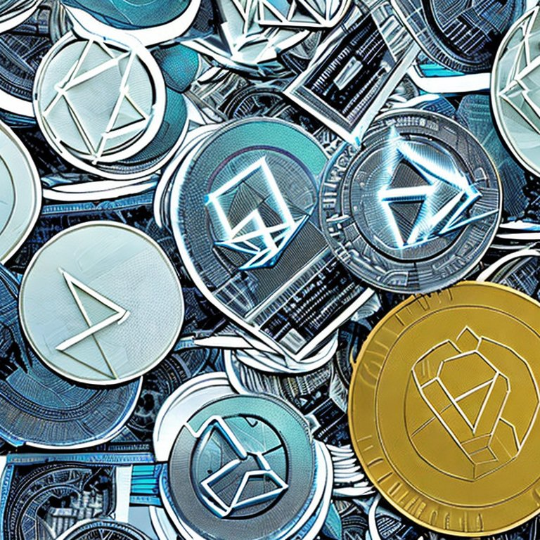

This perspective suggests that governments may be resistant to new technologies not necessarily because of the risks and challenges they pose, but because of the potential threats they may pose to the governments' own power and control. In this view, the adoption of new technologies may be seen as a double-edged sword, bringing both benefits and potential threats to the status quo. It is important to recognize that different governments may have different motivations and priorities when it comes to the adoption and regulation of new technologies, and that a nuanced and flexible approach may be necessary in order to find the right balance. An important consideration is that governments may also be resistant to new technologies due to lack of understanding or education on the potential benefits they can bring to society.

Dragon protocol introduces the concept of open-source, decentralized and adaptive governance as a means of maintaining aspects of democracy and liberty within a society subscribing to a technological version of the principles around anarcho-capitalism. This innovative hybrid political philosophy advocates for a society with decentralized consensus in the place of central planning and leadership, relying instead on the voluntary cooperation and mutual aid of individuals to govern themselves through self-amending distributed governance software. Dragon Protocol suggests a decentralized governance organization model that uses tokenization, where value is self custodied by network participants for use as voting power, to address leadership and trust within this framework.

An anarcho-capitalistic society is a visionary concept that combines the freedom and autonomy of anarchism with the economic efficiency and innovation of capitalism. In this type of society, individuals are free to engage in voluntary interactions with one another, without interference from any central authority or government. This philosophy seeks to create a society without leaders or a hierarchy of individuals in power. It is not a call for chaos or a lack of rules or governance systems, but rather a belief that power should be distributed evenly among individuals, rather than concentrated in the hands of a small group of leaders. This can be achieved through decentralized, autonomous systems that allow individuals and communities to govern themselves, rather than being controlled by a centralized authority. An anarcho-capitalistic society represents a radical departure from the traditional model of the state and its monopoly on the use of force. It is a bold vision that if combined with innovative modern technology, has the potential to revolutionize the way that society is organized and governed, and it represents an exciting opportunity for individuals to take control of their own lives and destinies.

An existing form of technological anarcho-capitalistic society that utilizes blockchain and decentralized consensus is a decentralized autonomous organization (DAO). A DAO is an organization that is run entirely by smart contracts, which are self-executing contracts with the terms of the agreement between buyer and seller being directly written into lines of code. Smart contracts allow for the automation of processes and the execution of contracts without the need for intermediaries or a central authority. This can be particularly useful in cases where it is difficult or impractical to have a third party involved, or where there is a need for increased transparency and trust.

Smart contracts can be written in a formally verifiable way in order to support mission critical systems. Formal verification is a method of proving the correctness of a system or system component through the use of rigorous mathematical techniques. It can be used to ensure that each function within the smart contract is free of errors and will behave as intended when deployed on the blockchain. There are several benefits to using formal verification in smart contracts. It can help to improve the reliability and security of the contract, as well as the trust and confidence of the parties involved. Formal verification can also help to identify and fix any errors or vulnerabilities in the contract before it is deployed, which can help to avoid costly and time-consuming issues down the line. In addition to these benefits, formal verification also allows for greater transparency and audibility of smart contracts, as the mathematical proofs can be easily shared and reviewed by all parties involved, providing a higher level of assurance and trust in the contract.

Smart contracts can be used for a wide variety of applications, including financial transactions, supply chain management, and the creation of decentralized autonomous organizations (DAOs). They can also be used to enforce the terms of agreements related to property ownership, intellectual property, and even employment contracts. In order to use smart contracts, both parties must agree to the terms of the contract and must have access to the same blockchain network. Once the terms of the contract have been agreed upon and the contract has been deployed to the blockchain, it cannot be altered or tampered with. This ensures the integrity and security of the contract, as well as the trust and transparency of the parties involved.

Decentralized applications (DApps) are software applications that run on a decentralized network and are built using blockchain technology. They are designed to be resistant to censorship, fraud, and downtime, making them a highly secure and reliable platform for a wide range of use cases. DApps are often powered by smart contracts and can be used to create decentralized marketplaces, prediction markets, and a host of other applications. The potential of decentralized applications is vast, as they have the ability to disrupt traditional business models and enable new, more efficient ways of operating. For example, a decentralized ride-sharing application could connect drivers and passengers directly, bypassing the need for a centralized company to facilitate the transaction and take a cut of the profits. Similarly, a decentralized supply chain management system could enable more transparent and efficient tracking of goods as they move through the supply chain. The use of decentralized applications is still in its early stages, but as adoption continues to grow, it can be expected that even more innovative and impactful use cases emerge.

A decentralized legal system is a smart contract platform, a digital platform that allows parties to create and execute contracts using code. Smart contracts can be used to automate complex legal agreements, such as contracts for the sale of goods or services, and they can be programmed to enforce the terms of the agreement automatically. Another example of a decentralized legal system is a community-driven dispute resolution platform, which allows individuals or groups to resolve disputes outside of traditional courts. These platforms often use decentralized technologies, such as blockchain, to create a transparent and secure record of the dispute and the resolution process.

* Smart Contracts

Adaptive Governance Systems (AGS) are a novel approach to governance that utilizes decentralization, free market principles, and distributed consensus through smart contracts to create a self-organizing system that can adapt to changing circumstances and respond quickly to new challenges. Both adaptive governance systems and on-chain governance as used by DAO’s rely on distributed consensus protocols, smart contracts, and self-sovereign digital IDs to enable secure communication and transparency among stakeholders. However, adaptive governance systems take this a step further by including additional elements such as open-source software methodologies and the dynamic evolution of the system itself. The AGS is responsible for making decisions about how the DAO operates and how its resources are allocated. It typically includes mechanisms for decision-making, such as voting or proposal systems, as well as ways to change or update the rules of the DAO. This allows for the AGS to continuously improve and optimize its performance, by updating the rules and processes in response to the stakeholders' feedback and changing circumstances.

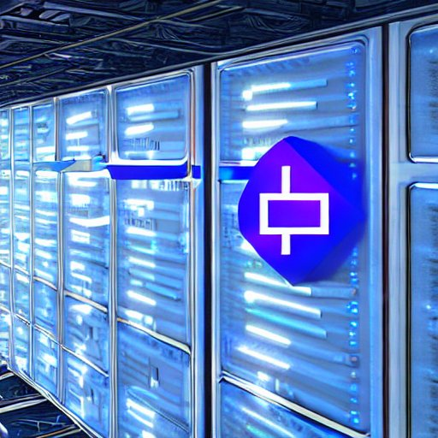

In a technological anarcho-capitalist society, AGS could be further enhanced by the integration of blockchain technology and cryptocurrency to create a digital governance market that serves as a means for voting in elections or policy changes. This would allow for a more efficient and transparent system where market forces drive decision-making and all stakeholders have equal access to the decision-making process through their ability to vote using cryptocurrency. AGS can create an adaptive governance software architecture that is more responsive, efficient, and adaptable than traditional centralized systems, and can serve as a backbone for a new economic and political system that replaces traditional forms of markets and voting.

Blockchain-based voting is a paradigm shift in the realm of governance, utilizing decentralized ledger technology to provide a transparent, secure, and tamper-proof method for conducting elections and decision-making. Smart contracts and distributed consensus protocols ensure fairness and impartiality, granting all stakeholders an equal voice in the outcome. The immutable and transparent nature of blockchain technology eliminates the possibility of vote manipulation or fraud, guaranteeing that the results accurately reflect the will of the community.

In contrast, traditional voting machines rely on closed-source hardware and software, creating potential vulnerabilities such as backdoors or the ability to alter votes. Paper-based voting systems also possess a higher risk of manipulation, errors, and mistrust in the voting process and outcome. Blockchain-based voting offers a technologically advanced solution that adapts to the changing needs of the community, fostering trust and participation among stakeholders. Overall, it represents a significant advancement in the evolution of governance.

It is often said that mathematics is the language of the universe because it’s a way of describing and understanding the patterns and structures that exist in the world around us. In this sense, a formally verified decentralized adaptive governance software could be seen as a tool for helping complex and diverse cultures and nations to harmoniously synergize and operate in parallel, much in the same way that mathematics is a tool for understanding and predicting the behavior of physical systems. In the context of complex and diverse cultures and nations, a formally verified AGS would provide a clear and transparent framework for decision-making and problem-solving within the DAO. Adaptive governance can be seen as an advanced decentralized digital governance platform that combines distributed consensus protocols, smart contracts, self-sovereign digital IDs, and open source software methodologies to enable secure communication, efficient resource allocation, and the dynamic evolution of the system itself. All this allows for the transparent and efficient operation of a DAO, and promotes trust and participation among stakeholders. These technologies work together to create a flexible and effective governance system that can adapt to the changing needs of its users.

Vehicle registration, among other functions typically handled by the Department of Motor Vehicles, could be seamlessly integrated into this decentralized governance model. This type of decentralized governance application would be particularly beneficial in a DAO-based world, where different groups within the organization may have vastly different systems and ways of doing things. By providing a clear and transparent framework for decision-making and problem-solving, this software would foster cooperation and collaboration among different groups within the interoperable DAO of DAO’s, allowing them to work together more effectively towards shared goals. Furthermore, because this type of software is adaptive, it will be able to evolve and change as the needs and goals of the AGS change over time. This would ensure that the governance system remains effective and responsive to the needs of the members it serves.

The advent of adaptive governance systems presents an opportunity to fundamentally alter the way in which governance is conducted. A decentralized adaptive governance application, enabled by the integration of self-sovereign digital identities, can provide a robust mechanism for decision-making and problem-solving within these organizations. The application, which can be accessed through a web interface and public API's, allows individuals and businesses to manage their interactions with the governance system in a secure, transparent, and adaptive manner. The application's decentralized architecture ensures a high degree of transparency and security, while its adaptive capabilities enable it to effectively coordinate and harmonize the actions of diverse stakeholders. This promotes cooperation and collaboration, and allows for the efficient and effective achievement of shared goals.

Adaptive governance represents a fundamental change in the way decision-making and problem-solving are approached. Rather than being constrained by bureaucratic inefficiencies and a lack of accountability, it prioritizes a community-driven approach that empowers individuals and businesses to take an active role in shaping the governance system. With the ability to interact with the governance system through web interfaces and public API's, individuals and businesses will have greater control and participation in the decision-making process. This new model of governance has the potential to set the standard for the digital age, promoting equity and power distribution.

* Adaptive Governance Systems

In order for individuals to participate in a decentralized governance system, the management of identity and personal information becomes increasingly important. Traditional systems for managing these things rely on centralized authorities, but decentralized identity (DID) and self-sovereign identity (SSI) are methodologies that offer a more secure alternative. By allowing individuals to control their own identity and personal information, these systems reduce the risk of data breaches and identity theft. They also enable individuals to selectively share their data with trusted organizations, rather than being required to share it with everyone they interact with.

In addition to improving security and privacy, DID and SSI systems can also enhance convenience and efficiency by allowing individuals to easily access various services and platforms using their own identity and personal information. However, it is important to carefully consider the potential risks and implications of government-issued digital identities. In some cases, these systems may be used as a means of surveillance or to abuse power, leading to the potential for negative consequences such as the denial of an individual or business to make financial transactions, buy certain products, use particular services or travel based on government-issued credit scores or other despotic authoritarian mechanisms.

To use and interact with these systems, individuals can use a digital wallet or application to store and manage their identity information. This can include personal information such as name, address, and date of birth, as well as credentials that can be used to verify their identity to others. To increase the validity of their digital identity, individuals can use multiple forms of verification, such as biometric data or multiple documents. In addition to these forms of verification, the ownership of domains, social media accounts, and other digital assets can also be verified using these systems. Digital identities within these platforms can also be used to sign contracts and documents, providing a secure and verifiable way to transfer ownership and complete transactions. This is typically done through the use of encryption hashes, which allow the digital identity to be locked with a private key and unlocked with a public key for verification. Digital identities can be used to prove authorship of works of art or documents, and can even be used to verify ownership of virtual and real-life real estate and assets without any central authority.

* Self-Sovereign Digital ID

Open-source refers to a philosophy and practice of freely sharing information and resources in order to create and improve upon existing technologies and systems through collaborative software development. This often involves the use of distributed revision control systems, which enable the tracking and management of changes to software over time through the maintenance of multiple copies on different computers. These systems have several advantages over traditional centralized systems, including greater resilience and collaboration. In the context of building interoperable distributed governance software, open-source principles and distributed revision control systems can be utilized to create transparent and accountable systems resistant to censorship and tampering. An example of such a system is the blockchain, which utilizes open-source principles and distributed revision control to record transparent transactions in a ledger that is verifiable by anyone.  
  
Open-source software can be seen as a more secure alternative to proprietary software due to its publicly vetted and peer-reviewed nature. Unlike proprietary software, the source code of open-source software is available for anyone to review and audit. This transparency allows for a greater number of individuals and organizations to identify and address any potential vulnerabilities or bugs within the code. Furthermore, the use of open-source software can help to prevent the introduction of backdoors or other malicious functionality, as any such efforts would be discovered during the review process. The wide distribution and adoption of open-source software also means that there are often many individuals and organizations with a vested interest in ensuring its security and stability.

In contrast, proprietary software often relies on a single entity or a small group of individuals to identify and fix vulnerabilities, leaving it potentially more susceptible to attack or compromise and less agile. The use of open-source software, therefore, can be seen as a means of reducing the potential for malicious activities and increasing the overall security of systems and processes.

It is crucial to develop a governance system using the open-source development model to ensure transparency and accountability. By sharing information openly and allowing for collaboration, it is possible to create a more democratic and transparent governance system that is responsive to the needs of the people it serves.

* Open-source software

The use of adaptive software architecture in the creation of governance frameworks, legislation, and decision-making processes offers numerous advantages. One of the main advantages is the ability to adhere to principles such as simplicity, transparency, design, solutions-oriented thinking, testing, mathematical rigor, efficiency and peer review which are often prioritized in open-source and software development methodologies in general. In contrast, governments and empires throughout history have consistently demonstrated a proclivity for deception, theft, political bias and corruption, and the pursuit of control and collusion. Implementing community driven continuous integrative software-based systems allows for a departure from these unfortunate but recurring characteristics of traditional governing bodies.

A DAO, or Decentralized Autonomous Organization, as mentioned before, is a type of organization that is run through a set of rules encoded into a smart contract on a blockchain. It is a form of digital governance in which decisions are made by a consensus of stakeholders rather than a central authority. This can be seen as an innovation because it allows for a decentralized, transparent, and efficient way of making decisions and allocating resources within an organization. The way a DAO functions depends on the specific rules and structure that it has been set up with. In general, a DAO will have a set of proposals that stakeholders can vote on, and the outcome of the vote will be implemented automatically through the smart contract. Some DAOs may also be adaptive by having mechanisms for dispute resolution or for changing the rules of the DAO itself.

One key feature of a DAO is that it is decentralized, meaning that it is not controlled by any single individual or entity. This can make it more resilient to censorship or interference, as there is no central point of failure. DAOs are also often transparent, as the smart contract and voting records are publicly accessible on the blockchain. This can help to build trust among stakeholders and ensure that the DAO is acting in the best interests of its members.

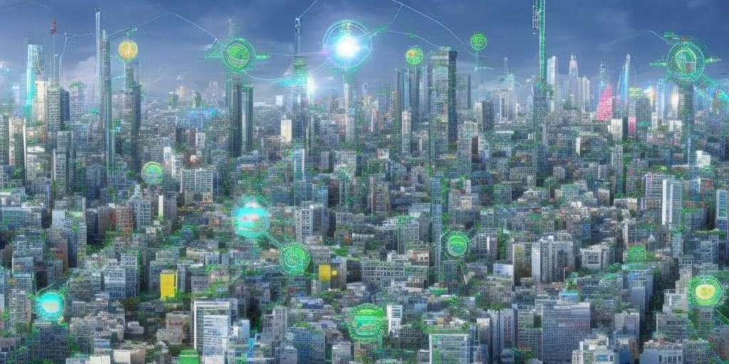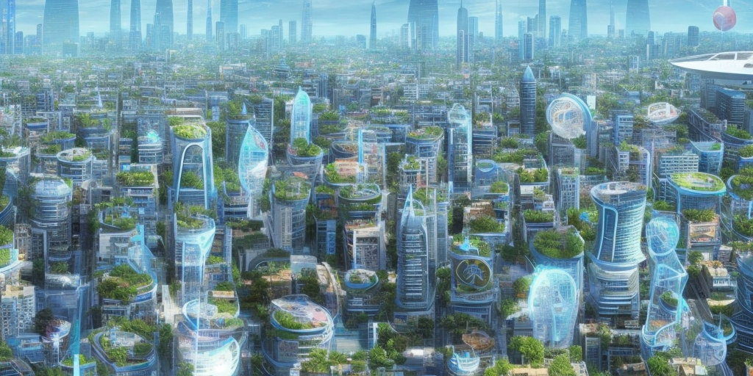

If all institutions, such as governments, corporations, and non-profits, were replaced with DAOs, it would fundamentally change the way society operates. DAOs use self-amending, adaptive governance, meaning the rules of the organization can be changed by its members through a democratic process. This would give individuals more control over the institutions that govern their lives, as they would have a direct say in how these organizations are run.

Additionally, interoperability between multiple DAOs would allow for greater collaboration and cooperation between different organizations. This would enable organizations to share resources and information, which would lead to more efficient and effective decision-making.

One way DAOs function in organizations is by using the power of smart contracts and network participant votes to elect individuals to specific positions within the organization. These individuals would be responsible for performing certain tasks and making decisions on behalf of the organization. The rules and guidelines surrounding the duration of these positions, as well as the qualifications and criteria for re-election, would be determined by the network participants through a self-amending process. This allows the organization to adapt to changing circumstances and address complex social issues more effectively. DAOs can help to eliminate centralized control and decision-making power, which can help to prevent corruption and promote transparency and fairness.

DAOs utilize various governance systems to make decisions and manage their operations, such as on-chain voting where members use their tokens to vote on proposals through a direct democracy system, which can be done using a simple majority vote or a more complex voting system like quadratic voting, which allows members to assign more weight to their vote based on the importance of the issue, making it less susceptible to manipulation by larger token holders. Another governance system is off-chain voting, where members vote on proposals using a voting platform that is not part of the blockchain, which can be more efficient but less transparent and secure.

Liquid democracy combines elements of direct democracy and representative democracy, allowing members to vote directly or delegate their voting power to a representative, while predictive markets use decentralized apps to make predictions about the outcome of a vote or proposal to inform decision-making. Expert review involves a panel of experts evaluating proposals before they are put to a vote to ensure they are well-informed and align with the goals of the DAO. Finally, DAO stack allows for customization of governance systems by combining different elements and creating custom rules, providing a set of modular building blocks that can be configured and combined to create a governance system tailored to the specific needs of the organization, allowing for greater flexibility and adaptability for the DAO as it evolves over time.

Interoperability between multiple DAOs would allow these organizations to more effectively address the broader social intricacies and complex relationships between groups of people. By utilizing interoperable networks and protocols, DAOs could communicate and coordinate with one another in order to address complex social issues and architectural challenges. Similarly, the use of standards like those developed by the International Organization for Standardization (ISO), which transcend national borders and allow people from anywhere to communicate and design technologies, products and services around a compatible set of parameters, would allow for greater interoperability and collaboration between DAO’s.

TCP/IP, the Transmission Control Protocol and Internet Protocol, is the underlying communication protocol of the internet. Its mathematical structure and open-source nature have allowed for seamless communication and collaboration between computer systems around the world, regardless of their location or the people using them. This has led to world-wide interconnectedness, enabling the exchange of ideas and information on a scale never before possible. One of the key features of TCP/IP is its decentralized structure, which means that there’s no central authority controlling the protocol itself, this allows for a level of freedom and innovation that is unparalleled.

The absence of central authority controlling the flow of information on the internet, ensures that the information is available to all, promoting transparency and democratization of knowledge, it enables people of all nationalities, cultural backgrounds, and religious belief systems to collaborate and communicate seamlessly, resulting in new technologies, businesses, and social movements, and greatly expanding the possibilities for global commerce and education. Just as the internet itself is a decentralized network, owned by no governing authority and operating on standards and software protocols alone, the use of worldwide standards promotes transparency and interoperability in the world market.

If law enforcement institutions were DAOs, they would be run and managed entirely by smart contracts, with no central authority or governing body. Decisions about how the organization should operate would be made through a voting process by the members of the DAO, and the smart contracts would be used to enforce those decisions and carry out the necessary actions. One possible benefit of using a DAO structure for law enforcement institutions is that it could help to ensure transparency and accountability, as all actions taken by the organization would be recorded on the blockchain and subject to review by the members. In addition, elected agents of these DAO’s would be subject to peer review, performance evaluations and term of office.

In a society governed entirely by DAOs, there would be more transparency and accountability, as the rules and decision-making processes of these organizations would be laid out in a clear and transparent manner. The use of smart contracts and network participant voting to elect human resources would also allow for more decentralized and familiar democratic decision-making within these organizations.

* Decentralized Autonomous Organizations

In a world with decentralized governance systems in the place of nation-states, different regions and communities would likely adopt different protocols and standards for their governance, depending on their specific needs and priorities. However, it is also possible that there could be a trend towards greater interoperability and compatibility among these systems, as they would need to be able to interact, standardize and exchange information with one another in order to function effectively. When governments are replaced with decentralized governance software, it is possible that nation-states would become more of a geological and historical/cultural reference rather than an actual identification of nationality. This is because decentralized governance systems are typically designed to operate independently of traditional political borders and structures, and they rely on decentralized technologies, such as blockchain and smart contracts, to facilitate interactions and enforce rules and agreements.

The emergence of decentralized governance models presents an opportunity for the transformation of traditional military structures towards a more transparent and equitable system. By fostering a culture of transparency across the entire industry, the potential for profit-driven warmongering can be eliminated. This shift towards decentralization could lead to the establishment of a distributed humanitarian aid task force, capable of providing swift and effective assistance to communities in crisis, while aligning with the values of decentralized governance. This forward-thinking approach would represent a fundamental shift towards a more equitable and just world.

Forecasting the progression and ramifications of decentralized governance structures presents a formidable challenge, particularly with regard to their potential impact on conventional nation-state and defense paradigms in an era characterized by a preponderance of cooperative dynamics. However, it is clear that decentralized technologies have the potential to fundamentally change the way that societies are organized and governed, and to shift power away from central authorities towards more decentralized and distributed models of decision-making. It’s possible that decentralized governance systems could lead to the dissolution of traditional militaries in favor of more distributed and collaborative approaches to addressing worldwide challenges. These technologies could provide alternative models for maintaining order in society, while also addressing the limitations and challenges of traditional systems. However, as these platforms mature and become more widely adopted, it is possible that the need for traditional institutions could diminish. Decentralized digital ledger technologies can be integrated into traditional systems in a way that enhances their functionality and resilience today.

Governments could use Bitcoin as legal tender, utilize blockchain technology to improve the transparency and security of their voting systems, financial institutions could use smart contracts to automate and streamline their operations. The use of blockchain in voting systems to prevent fraud and ensure the integrity of the electoral process. The decentralized nature of blockchain makes it difficult to alter or tamper with vote counts, as all copies of the blockchain would need to be altered simultaneously in order to affect the results. Supply chains could also benefit from this technology by using it to track the movement of goods and materials, which would improve transparency, security and reduce the risk of errors and fraud. In order to start using this technology, organizations need to understand the potential use cases and work with experts and organizations that specialize in these areas in order to develop and implement solutions that are appropriate for their specific needs.

The convergence of decentralization, free market principles, distributed consensus, smart contracts, adaptive governance systems, self-sovereign digital IDs, and open source software methodologies has the potential to fundamentally transform society. These elements, when integrated, have the ability to create a more functional and equitable reality. Imagine a decentralized world where individuals have the autonomy to make their own economic decisions, control their personal data and have a real say in shaping the governance of their society. This is a society where power is distributed among its citizens, and where people can participate in adaptive governance systems, utilizing the tools of cryptocurrency and governance markets to transform monetary value into influence over the constructs they operate within. This type of decentralized system is built on the principles of integrity, transparency, and innovation. It allows for a free and open system where individuals can actively shape their world and make their voices heard. This is a world where individuals can thrive, where innovation is fostered, and where the economy is driven by the collective efforts of its citizens. Collectively, communities can create a decentralized future where every person has the opportunity to reach their full potential, and where monetary value can be transformed into real influence over the constructs of society. Through values like integrity and transparency, the world can build a system that is truly open, free and adaptive for all.

This vision is within reach, thanks to the innovative technologies and concepts we’ve explored so far. Decentralization allowing for the distribution of power, reducing the concentration of control in the hands of a few actors. Free market principles enabling the free exchange of goods and services, promoting economic growth and innovation. Adaptive governance systems leverage cutting-edge technologies including distributed consensus protocols, smart contracts, self-sovereign digital IDs, and open-source software methodologies to establish a clear and transparent framework for decision-making and problem-solving within decentralized autonomous organizations (DAOs). This advanced platform enables secure communication, efficient resource allocation, and dynamic evolution of the system, which ultimately promotes trust and participation among stakeholders. The integration of these technologies allows for a highly flexible and secure governance system that can adapt to the ever-changing needs of its users, ensuring the efficient and effective operation of the protocol.

Dragon's fire can be harnessed to forge a new world, one that is decentralized, fair and efficient. The tools to shape a brighter future are available, but it is important to use them wisely and construct a foundation that will endure. Collaboration is crucial to dismantling old systems and smoothly transitioning to new ones. By working together, a desirable outcome can be achieved.

3: Programmable ENERGY

Energy is the foundation of life, consciousness, and the universe. It’s indestructible, transformable and immortal, making it a perfect store of value. It’s adaptable and fully transportable unlike any other commodity in existence. This concept of using energy as a form of value storage marks a new era in the way society views and utilizes resources. It has the potential to revolutionize the way people store and transfer value, creating a more efficient, secure and decentralized economy. The ability to store value in the form of pure raw productive force, that can't be confiscated, tampered with or destroyed, makes it an ideal form of digital property for storing value in a world where digital assets are becoming more prevalent.

The centralized model of energy production and distribution, where nation-states maintain a monopoly through state-owned utilities or regulations that favor large energy companies, is ripe for disruption. The realization of alternative energy sources and distributed energy systems has the potential to fundamentally transform the generation and trade of electricity. Decentralized energy production refers to the generation of energy at or near the point of consumption, rather than relying on centralized power plants. This approach allows for greater energy efficiency, as energy can be generated and consumed locally, reducing transmission losses. Additionally, it allows for greater control and participation by individuals and communities in the energy production process. Decentralization of energy production and distribution can empower individuals and communities to take control of their own energy needs. By harnessing the power of the sun, wind, and other renewable sources, individuals and communities can generate their own electricity and even sell excess back to the grid or directly to others through peer to peer interactions.  
  
Programmable energy represents a paradigm shift in generating, distributing, and consuming energy. By leveraging advanced software and technology, individuals and communities can be empowered to take control of their own energy needs, and break free from the centralized model of energy production and distribution. With the ability to monitor, control, and optimize energy usage in real-time, programmable energy systems can greatly improve energy efficiency, reduce costs, and increase the integration of renewable energy sources into the grid. This not only increases energy independence and resilience, but also helps to diversify the energy mix and reduce reliance on fossil fuels. Programmable energy is the foundation for the decentralization of energy production and distribution, thus creating a more sustainable, equitable, and resilient framework around electricity.

The distributed electrical grid, enabled by programmable energy, represents a revolutionary approach to electricity generation, transmission and distribution. By decentralizing power sources and leveraging advanced technologies such as blockchain, this approach offers several key advantages over traditional centralized models. Firstly, it improves the stability and resilience of the grid by reducing the risk of blackouts or other disruptions. Secondly, it allows for more efficient use of resources and can help to reduce transmission losses. Thirdly, decentralized energy generation promotes the use of renewable energy sources such as solar, wind power, and even nuclear fusion, reducing the world’s dependence on fossil fuels and promoting energy security. Furthermore, blockchain technology can be used to facilitate peer-to-peer electricity trading, enabling individuals and communities to generate, buy, and sell electricity directly with each other, bypassing traditional intermediaries, promoting decentralization of power, and allowing for greater transparency, security, and efficiency in the electricity market. Ultimately, programmable energy and distributed electrical grid are the key enabler for a sustainable, efficient, and equitable energy future.

Energy has several properties including being measurable, conserved, and transferable. It is also a scalar quantity, meaning it only has magnitude and no direction. Energy is a good store of value because it can be easily stored and transferred, and can be converted into other forms of energy. This means that the total amount of energy in a closed system remains constant, although it can change forms. For example, the chemical energy in a battery can be converted into electrical energy, but the total amount of energy remains the same.

In contrast, physical property can be damaged or depreciated over time, and can be subject to taxation or governmental seizure. Similarly, physical property can be corroded or depreciated, but energy cannot. Energy can also be considered a store of value, similar to gold or other precious metals. It is a finite resource, and its value can change depending on supply and demand. Additionally, energy is essential for economic growth, and the ability to access and utilize energy resources is crucial for the development and prosperity of a society.

This is why energy is considered one of the most valuable resources on earth and is the backbone of many industrial and infrastructure projects. Energy is a necessary resource for powering many industrial and technological processes. This makes it a valuable commodity for a wide range of industries, making it an attractive store of value. Energy is also a store of value because it is a finite resource that is in constant demand. This means that as the population and economy continue to grow, the demand for energy is likely to increase, making it a valuable asset to own and produce.

Blockchains, decentralized digital ledger technology, can be utilized as the foundation for open-source energy trading platforms that enable peer-to-peer trading of electricity. Additionally, these solutions can be used for grid management, by allowing for the tracking and optimization of energy usage and distribution. This creates new business models and opportunities for individuals and communities to participate in the electricity market and foster greater energy sovereignty. By leveraging the transparency, security and immutability of blockchain technology, individuals and communities can take ownership of their energy production and consumption, and have greater control over the generation, distribution and visualization of electricity. The implementation of this strategy enables the establishment of a decentralized energy market structure, characterized by increased participation from individual and commercial entities, enabling them to capitalize on the opportunities arising from the integration of renewable energy sources, such as solar and wind power, within a dynamic and ethical energy infrastructure.

The use of energy in Bitcoin’s proof-of-work consensus creates a standing wave of encrypted electricity that serves as a solid form of value, as the energy used in mining creates a physical and measurable process that is used to validate and secure the blockchain. By requiring significant computational power to solve complex mathematical problems, PoW creates a tangible cost of energy expenditure that acts as the backbone of the network's value. This scarcity is what makes the digital assets, like Bitcoin, valuable. In a world where energy is abundant, PoW gives value to energy by creating a scarce resource that is required to secure the network and create new Bitcoin. This creates new business models and opportunities for individuals and communities to participate in the energy market and foster greater energy sovereignty. The integration of renewable energy sources such as solar and wind power within the PoW mechanism allows for individuals and businesses to have control over their energy production and consumption, while also benefitting from the opportunities presented by blockchain technology and digital assets. This approach also promotes a more democratic distribution of power and control within the network, as anyone can contribute to the network's security through participating in the PoW process.

Even after all 21 million Bitcoin are mined, the network will continue to rely on the PoW to secure the transactions, creating a cost that is proportional to the energy used to perform it. This ongoing work not only maintains the value of the network but also the digital assets it safeguards. PoW's ability to harness energy consumption has led to the creation of dynamic arrays of Bitcoin miners that consume excess energy in situations where oil or other natural resources would otherwise be flared (burned) or wasted to prevent energy surges. By harnessing the power of distributed computing and blockchain technology, miners are able to turn excess energy into network security and valuable cryptocurrency, helping to mitigate the effects of energy imbalances and prevent the waste of natural resources. PoW's energy consumption can also be harnessed to support the development of renewable energy sources. For example, miners can choose to locate their operations in areas with abundant renewable energy resources such as hydroelectric, solar or geothermal power, and thus indirectly contribute to the growth of these industries.

Another important aspect of PoW is the concept of difficulty adjustments. Difficulty adjustments are implemented to ensure that block creation time remains consistent, regardless of the number of miners participating in the network. This is achieved by adjusting the difficulty of the PoW algorithm so that blocks are mined on average every 10 minutes. By doing so, the network is able to maintain a stable rate of block creation, which in turn helps to ensure the security and stability of the network. Additionally, in times of need, energy can be diverted from Bitcoin datacenters to neighboring towns and cities by de-allocating a percentage of miners that would usually be consuming that energy, thus PoW not only creates value but also helps to prevent energy waste and contributes to the overall balance and stability of the future grid.

The true revolutionary potential of Bitcoin and blockchain technology is not simply in their ability to consume excess energy, but in their ability to program electricity. By leveraging the power of smart contracts and decentralized networks, these technologies can be used to create programmable energy and programmable value, enabling new forms of economic activity and social organization. The advancement of distributed computing, fusion technology and blockchain, have a significant impact on the energy sector. Distributed computing allows for the decentralized generation and distribution of energy, enabling local communities to generate and manage their own energy supply. Blockchain technology, on the other hand, enables the secure and transparent tracking of energy transactions, creating a more efficient and transparent energy market.

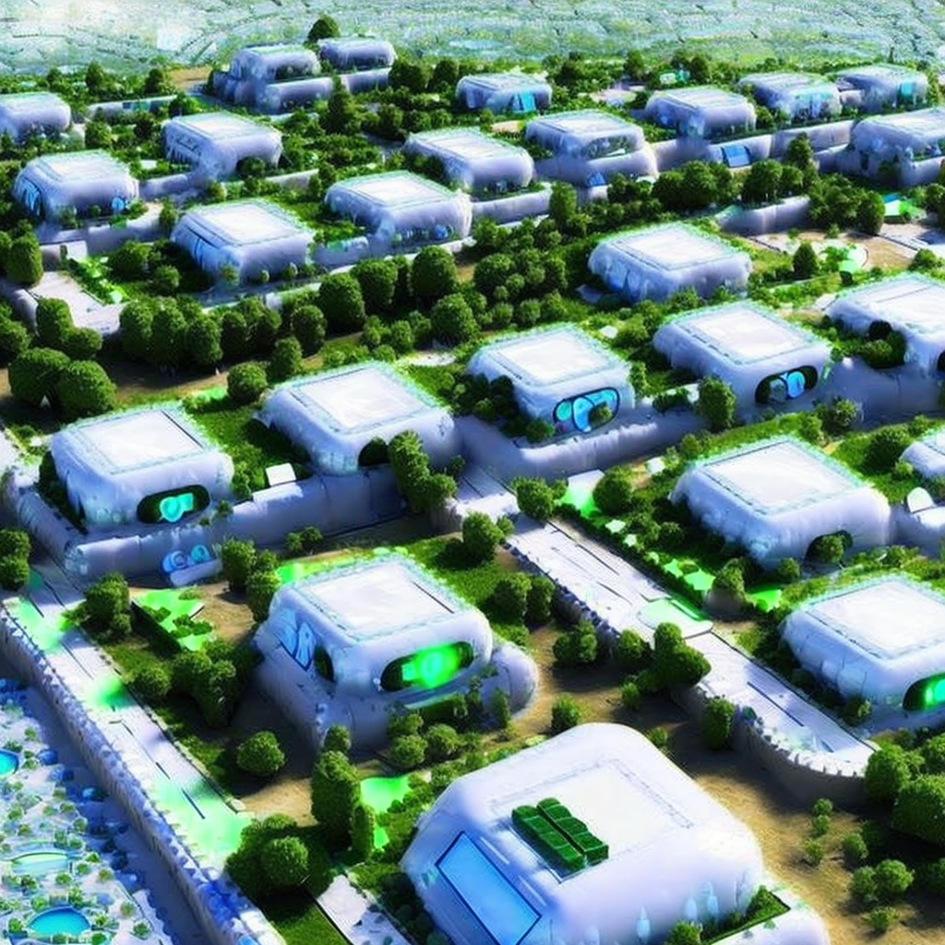

Nuclear fusion, the process of combining atomic nuclei to form heavier elements, has the capability to revolutionize the energy sector by providing a sustainable and clean energy source. Unlike traditional fossil fuels, nuclear fusion does not produce harmful greenhouse gases or air pollutants. Additionally, it does not produce the long-term radioactive waste associated with nuclear fission. With ongoing research and development in this field, the potential for nuclear fusion to play a major role in meeting the increasing global energy demand becomes increasingly tangible. When fusion technology is combined with the advancements in distributed computing and blockchain technology, the results are truly transformative.

The advancement of fusion technology and the abundance of clean and renewable energy it brings, has the potential to fundamentally transform the way societies organize and value energy. As the cost of electricity drops to near zero, it becomes possible for everyone to have access to affordable, reliable energy. In this future, blockchain technology serves as the foundation for a decentralized energy market that allows for the buying and selling of energy in a transparent and secure manner. The proof-of-work mechanism, enables the creation of value in a world where energy is so abundant that it is otherwise impossible to value.

The decentralization of the energy industry and the internet infrastructure is a transformative movement that brings many benefits to individuals and communities. By moving away from centralized systems controlled by government institutions and monopolies, communities are able to establish a more resilient and equitable infrastructure that is owned and controlled by the people who use and build the network.

In the case of energy, decentralization enables the concept of energy sovereignty, where individuals and communities are empowered to produce, distribute and consume energy in a way that meets their specific needs and goals. This is facilitated by the integration of distributed energy resources such as rooftop solar panels, microgrids, and battery storage systems. Similarly, the decentralization of the internet infrastructure enables the creation of a distributed network of nodes, where individuals can broadcast their own wireless internet signals and operate as distributed ISPs. This creates a more robust and censorship-resistant internet, where individuals are incentivized to provide access to the decentralized web by being paid in cryptocurrency.

The convergence of decentralized energy grids and the decentralized internet presents an exciting opportunity for the integration of these two systems, creating a shared energy and internet grid that is owned and controlled by its users. This integration allows for the transfer of data and energy over the same infrastructure, enabling new forms of communication and commerce while also increasing the overall resilience of the network. The future of energy and the internet is one where individuals and communities are empowered to take control of their own resources and shape the infrastructure that supports their daily lives.

Decentralized application layers built on blockchain technology enable the creation of decentralized virtual worlds where individuals and organizations can mine, own and control fungible and non-fungible digital assets, unconfiscatable digital mechanisms and properties. Integrating virtual worlds with a decentralized energy grid enables the efficient management and balancing of energy consumption through the use of digitally signed virtual assets. These virtual assets act as proxies for physical mechanisms, facilitating the transfer of value between the physical and cyber worlds.

This integration creates a dynamic equilibrium between energy consumption and production, allowing for the optimization of energy usage in virtual environments while maintaining the overall stability of the decentralized energy grid. This innovative approach to energy management enables the realization of a truly interconnected and mutually beneficial relationship between virtual worlds and the decentralized energy grid. As energy demand fluctuates on the grid, the flow of energy directed towards the blockchain-based virtual world adjusts accordingly. This creates an intelligent programmable layer that incentivizes balance between the physical and digital worlds through tokenization and arbitration of programmed electricity, promoting equilibrium and efficiency. This adaptive informational layer opens up new opportunities for innovation and growth in both worlds, fostering a future where technology and society are in sync with freedom, integrity, immutability, and self-sovereignty.

The energy consumption of the Bitcoin network is currently estimated to be around 204 TWh per year, equivalent to the energy consumption of a small country like Colombia or Israel, or 0.5% of total global energy consumption. As the network approaches mining of the last Bitcoin, the energy and computing power required to do so will increase dramatically. This could potentially lead to an astronomical increase in energy consumption, making it crucial for the world to advance in clean and renewable energy production to sustain this demand. However, it is important to note that this increase in energy consumption is not a negative outcome.



Securing the world reserve currency is a virtuous aim, and an opportunity for humanity to advance, unite and invest in unlimited renewable energy sources. The finite supply of 21 million Bitcoin makes it an absolutely finite digital asset and the pursuit of the last Bitcoin will drive the world to research and invest in unlimited renewable energy. As a side effect of this pursuit, energy grids will become more decentralized, agile, resilient, programmable, and stable. The decentralized consensus mechanism provided by proof-of-work is coupled with the halving cycle, which controls the supply of new Bitcoins. Halving occurs every 210,000 blocks, or roughly every four years, and it cuts the rate of new Bitcoins being created by half. This gradual decrease in supply results in a deflationary currency, which means that the value of Bitcoin increases over time. This is beneficial for holders of Bitcoin as it can be expected that their assets will appreciate over time. On top of that, the decentralized consensus mechanism allowing for the transfer of value without the need of intermediaries or central authorities, which can unlock a cascade of decentralized technologies that improve many sectors of society.

This makes Bitcoin a valuable asset and worth the energy consumption and advancements in computing and inter-connectivity needed to participate in this ever-growing network. Moreover, traditional fiat currency, such as cash and coins, incurs high costs in its production, transportation, and operation. The process of printing and minting paper money and coins can only be done by self proclaimed central banks and requires significant amounts of energy and resources. Additionally, the maintenance and operation of Banks, ATMs, and point of sale machines in almost every brick and mortar also adds to the expenses. These costs can be quite substantial and contribute to the overall expense of using fiat currency, which is another incentive for individuals and organizations to switch to a decentralized digital currency like Bitcoin.

ASIC (Application-Specific Integrated Circuits) processors, used for mining and validating blocks on decentralized networks, are arguably the most valuable use of energy and ingenuity imaginable. These processors, and the energy they consume, play a crucial role in maintaining the security, independence, flexibility, and stability of decentralized systems by ensuring the integrity of transactions through the use of distributed consensus. This technology has the potential to eradicate corruption and deception in the world by creating fully transparent, adaptable, and immutable systems that remove the need for centralized authorities such as institutions and nation-states. In this way, the energy consumption of ASIC processors can be seen as a noble cause, as it supports the creation of a more fair and just society, where power is in the hands of the people and not centralized entities.

Distributed consensus is the logical next step for an advancing civilization. Bitcoin's energy usage is a trade-off for the security and decentralization that it offers. As the world mines the last Bitcoin, the energy and computing power (hashrate) needed will increase dramatically, making it crucial for the world to advance in clean and renewable energy production to sustain this demand. This could be seen as an opportunity for humanity to unite in the pursuit of cleaner and more sustainable energy sources and pave the way for a self-sovereign monetary, financial, and energy renaissance. ASIC manufacturing and the ever-increasing hashrate of proof-of-work consensus will drive innovation, standardization, cooperation, and unity across industries needed to create and maintain the most important aspects of the decentralized and future full of freedom and creativity, unlimited stable energy, and decentralized consensus systems. To achieve this, the world must foster a culture of cooperation and collaboration across industries, governance systems, and communities. This includes sharing data and expertise, investing in research and development, and working together to develop and implement new technologies. By embracing a spirit of partnership, communities can overcome the challenges humankind faces and create a future where energy is abundant, accessible, and sustainable for all. This will require an active effort to mobilize resources, share knowledge, and collaborate across sectors, as well as support from governance, private organizations, and individuals. Together, communities can build a more sustainable energy system that is equipped to meet the demands of a decentralized economy, while also making significant strides towards a more sustainable future for all.

The achievement of a sustainable and equitable future for humanity can be realized through the implementation of standardization and open-source protocols in technology development and maintenance. These protocols provide a framework for collaboration and cooperation among groups, while preserving authenticity and individuality. By utilizing these protocols, people of the world can create a shared infrastructure for all of humanity, similar to the universality of the internet, to tackle pressing issues such as energy, healthcare, and transportation. Attaining the apex of technological evolution entails the realization of a limitless, inexpensive and distributed energy source, coupled with a decentralized application layer that enables the most advanced and secure monetary and governance systems conceivable. This synergistic integration of energy and decentralized technology has the potential to revolutionize the way in which society operates, providing unprecedented levels of autonomy, security, and efficiency. It represents a paradigm shift towards a more equitable, decentralized and sustainable future, where power is vested in the hands of the many, rather than the few.

The opportunity to contribute to the development of such a revolutionary technology is truly inspiring, and represents the ultimate challenge and opportunity for those who seek to shape the future of mankind. The implementation of open-source manufacturing techniques presents a transformative opportunity for individuals and communities to collaboratively design, develop and manufacture advanced alternative energy technologies, such as fusion reactors, across geographically dispersed locations. The utilization of open-source principles allows for the democratization of knowledge and expertise, enabling a community-driven approach towards creating optimized, sustainable energy solutions. This decentralized network of energy producers and consumers, guided by a collective of experts in the field, has the potential to revolutionize the way in which energy is produced and distributed, leading to a more equitable and efficient energy system.

The creation of a self-sovereign decentralized energy grid represents a significant advancement in energy production and distribution, as it allows for the decentralization of power generation and distribution, thus increasing resilience and security. However, it also has implications for the field of communications and information technology. Energy can be and often is encoded with vibrational information, which means that the energy grid can also be used as a network for transmitting data. This creates a robust and decentralized communications network, similar to the internet. This concept is often referred to as an "Internet of Energy." By leveraging the existing infrastructure of the energy grid, this network can be created without the need for additional infrastructure, making it more cost-effective and efficient. Furthermore, the decentralized nature of the network increases its resilience, as the failure of one node does not result in the failure of the entire network. This creates a system that is not only more efficient and cost-effective, but also more secure and resilient. The potential for this technology to revolutionize the way the world thinks about energy and communications is truly exciting, and it represents a significant step forward in creating a more sustainable, censorship resistant and connected future for humanity. The marriage of open-source manufacturing, information technology and decentralized energy production represents a significant and truly inspiring opportunity for those who seek to shape the future of energy and information. It allows for the customization and mass production of renewable energy systems at a low cost, while also enabling individuals and communities to take ownership of their energy and information production, transmission and consumption. This approach can promote decentralization and democratization of the internet and worldwide energy system, enabling more equitable access for all.

By committing to these objectives, humanity has the opportunity to reach its highest potential and fully harness the power of programmable energy systems without limits. Love, as the ultimate form of organization, represents the process by which diverse groups adapt and come together in mutually beneficial ways. It is through this process that harmony and abundance can be achieved, as individuals, businesses and communities work together towards shared success. Through alignment with these principles, the path towards a sustainable and equitable future for all becomes clearer.

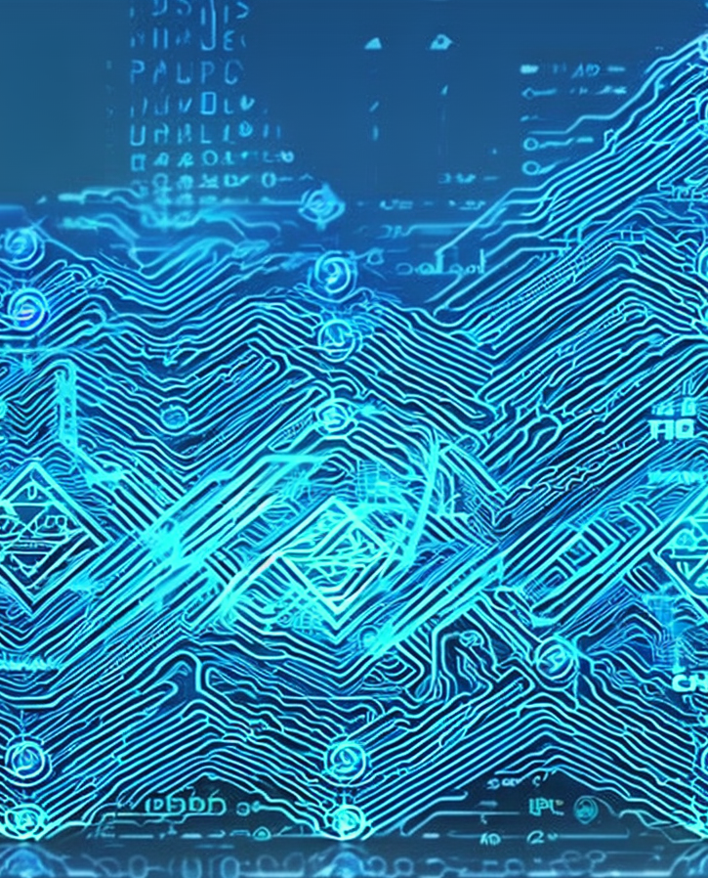

4: ARCHITECTING ALCHEMY

The deployment of a dynamic, boundless energy grid and adaptive governance models holds the potential to alleviate a substantial portion of the world's challenges. However, as a world community, it is vital that communities strive towards streamlining and optimizing the various industries and infrastructure currently in place, in order to effectively launch this initiative and drive towards a more efficient and prosperous future.

Alchemy, a medieval branch of natural philosophy, embodies the idea of purifying, maturing, and perfecting certain objects. In the context of making components of industries more optimized and multi-functional in order to generate more energy or productivity, alchemy can be thought of as a metaphor for the process of transforming something with a single use case or function into something that has multiple uses or functions.

Multi-use structures are buildings or structures that are designed to serve multiple purposes. For example, a multi-use building might contain both commercial and residential spaces, or a combination of retail, office, and industrial spaces. This concept of multi-use products and services can be likened to the idea of alchemy, where one substance is transformed into multiple forms, each with its own unique properties and uses. Similarly, multi-use products and structures have multiple surfaces for functions, providing a variety of services and resulting in a net positive of energy or optimization.

For example, in construction, multi-use structures act as a polygon with multiple aspects, providing services such as places of residence, business, and agriculture, all while utilizing sustainable energy sources like solar and wind power, and incorporating features like rainwater capture and water filtration for agricultural use. This results in a reduction of additional resources and an increase in overall efficiency, promoting a more sustainable way of living. Using structures for more than one purpose aligns with decentralization as it enables each unit to function as a node that provides multiple services to the local section of the system it’s a part of. By incorporating multi-use structures into city planning, cities can improve transportation and safety by reducing the need for people to travel long distances to access different types of services or activities.

One way to achieve this is through the use of decentralized city planning techniques. Instead of having a centralized city center, with all the commercial, residential, industrial, and agricultural zones concentrated in one area, cities can be split up into smaller sections, each containing a mix of different zones. This would distribute resources more evenly across different geographic locations, reducing the need for long-distance transportation and improving overall efficiency and resilience.

The decentralized model can promote the use of advanced technologies like sharding or splitting up cities and zones into smaller sections. This allows for a more efficient and resilient city structure, as each section could be designed to meet the specific needs of the community it serves. A commercial zone could be designed to be more pedestrian-friendly, while an industrial zone could be designed to optimize the movement of goods and vehicles.

By incorporating these concepts into city planning, communities can create more sustainable and livable cities for the future while reducing the potential for supply shortages. Multi-use structures are a key element in sustainable urban design and planning, as they allow for the efficient use of resources, reduction of waste, and increased energy production. By designing buildings and infrastructure that can serve multiple purposes, such as residential, commercial, and community spaces, communities can create a more cohesive and resilient urban environment.

One way to accomplish this is through the use of bio-mimicry, which involves emulating the patterns and principles found in nature to create more efficient and sustainable human-made systems. For example, many plants use mathematical algorithms to optimize their growth and absorption of sunlight, adapting to their surroundings in the most efficient way possible. By applying these same mathematical principles and geometries to the design of city structures and planning, cities can create a built environment that is more in tune with the natural systems around it, leading to increased energy production and higher quality of life for individuals and businesses within the system.

In addition, this model can be expanded to city planning and architecting, where instead of designing buildings as isolated entities, they can be designed as interconnected systems that work together to create a more sustainable and resilient urban environment. This can include utilizing green roofs and walls, integrating renewable energy sources, and designing for walk-ability and bike-ability to reduce dependence on cars. Mathematics play a huge role in natural systems, and many natural phenomena can be described and predicted through mathematical models. For example, the Fibonacci sequence is a mathematical pattern that is found in many natural systems such as the branching patterns in trees and the spiral patterns in seashells and pinecones. By understanding and applying these mathematical patterns in the built environment, the world can create more efficient and sustainable systems that mimic the resilience and harmony found in nature. In essence, multi-use structures, bio-mimicry, and utilizing mathematical principles found in nature, can lead to the creation of more energy efficient and sustainable communities, resulting in higher quality of life and prosperity for individuals and businesses within the system.

Likewise, utilizing multi-use raw materials in various existing industries can bring significant benefits such as versatility and sustainability. Adopting raw materials that have versatility also promotes sustainability by reducing dependence on resources with limited applications. Furthermore, it aligns with the concept of decentralization, creating a more distributed and resilient supply chain. This approach reduces the risk of supply shortages, and increases the distribution of resources, reducing the need for long-distance transportation and improving efficiency and resilience.

The hemp and cannabis industry for example, is a paradigm of versatility, boasting a multifaceted array of applications and services. The hemp and cannabis plant, also known as industrial hemp and marijuana, is a highly versatile crop that boasts a diverse array of applications, including food, medicine, concrete, steel, bio-plastic, textiles, fuel, paper, and cosmetics. Industrial hemp is a rapidly maturing and versatile raw material, it has the potential to revolutionize multiple industries through its ability to be grown to maturity in a single growing season, as compared to traditional raw materials such as trees which can take decades to regenerate. Furthermore, the plant is also rich in terpenes such as limonene, myrcene, and linalool, which are being extensively researched for their unique therapeutic properties. Additionally, the plant's medicinal properties, specifically compounds like cannabidiol (CBD) and tetrahydrocannabinol (THC) have been extensively studied and have been scientifically proven to effectively treat a wide range of conditions and ailments. This versatility makes hemp and cannabis a valuable resource that has the potential to revolutionize many industries, but also poses a threat to many corporations who rely on traditional materials and products. These corporations often lobby against the proliferation of hemp and cannabis, as it could disrupt their business models and reduce their profits.



Similarly, the cultivation and utilization of innovative raw materials such as corn, rice, algae, bioplastics, graphene, carbon fiber and wood-based materials, have the potential to revolutionize multiple industries through their versatility and sustainable characteristics. Algae, for instance, can be used to produce biofuels, energy, the field of medicine, and is known for its ability to grow quickly and in a variety of environments.

Bioplastics, also known as bio-based plastics, are a sustainable alternative to traditional fossil-fuel based plastics as they are made from renewable materials such as corn starch, sugarcane, plant cellulose. One example of a bioplastic that is currently in use is Polylactic acid (PLA), which is produced by fermenting the sugars found in plants like corn, sugarcane, or cassava, or using the cellulose from hemp. These materials can be replenished relatively quickly in comparison to non-renewable fossil fuel-based plastics. PLA can be processed using existing plastic manufacturing techniques, and can be used to make a wide range of products, including automotive parts, building materials, and even medical devices. Bioplastics are considered to be more environmentally friendly than traditional plastics, as they are biodegradable and can be broken down by microorganisms into natural substances like water and carbon dioxide, which means that they do not contribute to the problem of plastic waste in landfills and the environment. Additionally, bioplastics can be recycled or even used as a source of energy through incineration, which is not the case for traditional plastics. The manufacturing process of Bioplastics also has a smaller carbon footprint than traditional plastics production. The manufacturing of traditional plastics, such as Polyethylene (PE) and Polypropylene (PP), necessitates a significant energy input and results in a substantial emission of greenhouse gases. Additionally, the recycling efficiency of these traditional plastics is suboptimal. In contrast, the production of bio-based plastics such as PLA, using hemp as raw material, uses significantly less energy and releases fewer greenhouse gases. The use of bioplastics in a Cradle-to-Cradle manufacturing technique has the potential to revolutionize the way people produce and consume plastics, making the entire process more sustainable, less impactful on the environment and also using a resource that is abundant and can be grown easily.

While bio-plastics offer a more sustainable alternative to traditional plastics, regenerative gardening and other beneficial farming techniques can take it a step further by not only reducing waste but also improving soil health and biodiversity. Regenerative gardening is a holistic and systemic approach to gardening and farming that aims to not just maintain, but improve the overall health, fertility, and resiliency of the soil. This is achieved through the implementation of techniques such as utilizing cover crops, crop rotations, composting, and promoting the growth of beneficial microorganisms to create a self-sustaining and regenerative ecosystem that can support plant growth without the need for external inputs, such as fertilizers and pesticides. Additionally, regenerative gardening aims to reduce water usage, increase biodiversity, and promote carbon sequestration through practices such as no-till farming, agroforestry, and holistic planned grazing. Furthermore, the integration of agriculture into multi-use buildings and structures through the use of hydroponics not only increases decentralization of crucial resources, reducing the likelihood of supply disruptions and outages, but also reduces the pressure on transportation infrastructure by making resources more evenly distributed and accessible. To fully realize the potential of these innovative and regenerative practices, it is essential to foster an environment that allows for unrestricted development and proliferation in the marketplace, driving progress and innovation.

Precision Agriculture, Conservation Agriculture, Permaculture and Organic farming are just a few more innovative techniques that can revolutionize the way food is grown and land is managed. Precision Agriculture uses technology such as drones and sensors to gather data on crop growth and soil health, allowing for more efficient and precise use of resources, helping farmers to make better decisions about when to plant, when to irrigate, and when to apply fertilizers, leading to more efficient use of resources and higher yields. Conservation Agriculture focuses on minimizing soil disturbance, maintaining soil cover with crops or other vegetation, and rotating crops to improve soil health and reduce erosion, creating a more sustainable and resilient agricultural system. Permaculture is a holistic approach to farming that mimics natural ecosystems and focuses on creating self-sustaining systems that use minimal inputs, considering the interactions between different elements of the ecosystem, such as plants, animals, and microorganisms.

Organic farming avoids the use of synthetic fertilizers, pesticides, and genetically modified organisms, instead relying on natural methods to control pests and diseases and to fertilize the soil, promoting biodiversity, sustainability, and improving the nutritional value of the food produced. Together, these techniques have the potential to create a more sustainable and resilient agricultural system that can provide food security and improve the quality of life for farmers and the communities they serve. Primarily plant-based food production, advanced agricultural techniques, and converting excess animal-based farming operations to manure producing livestock sanctuaries, it is possible to create a sustainable and efficient system for producing food while down cycling the use of factory farming. This would also have the added benefit of reducing the carbon emissions and natural resource consumption by animal-based food industries, reducing pressure on the environment and promoting ethical business practices. Almost every edible plant contains proteins, even if in small amounts, and a wider variety of amino acids than any meat or dairy-based alternative. This diversity of amino acids is important for maintaining optimal health, and can prevent deficiencies that are common with a diet that relies heavily on animal-based proteins. Additionally, plants are highly regenerative and provide a wide range of other essential nutrients, including vitamins, minerals, antioxidants, and phytochemicals, which are important for maintaining optimal health and preventing disease.

This is a call to action, to innovate and strive for a better future through technology and re-structure of governance models and societal platforms to support it. Current infrastructure can be viewed as raw materials for a new alchemy that transforms them into a multi-functional, efficient, and sustainable system, thereby improving overall well-being of society. Imagine a world where products and systems are not just sustainable, but actively regenerative. This is the vision of Cradle to Cradle manufacturing (C2C), a design philosophy and approach that aims to create products and systems that are not only efficient and sustainable, but also regenerative.

C2C manufacturing is a revolutionary approach that shifts the paradigm of traditional "cradle to grave" manufacturing. Instead of viewing products as disposable and natural resources as finite, C2C views materials and resources as cyclical and endlessly reusable. It prioritizes the use of materials that can be easily and safely recycled or repurposed, conserving natural resources and energy, while promoting the use of bioplastics and biometals. Additionally, it encourages the use of closed-loop systems, where waste from one process becomes the input for another, leading to more efficient recycling potential and the creation of new products and materials. By incorporating transparency and intelligence into the design, production and consumption of products, a more informed and engaged consumer base can be created, driving the market towards more sustainable products and practices, while promoting a more responsible and equitable use of resources.

To enhance this approach, C2C manufacturing, combined with blockchain-enhanced, opensource supply chain transparency, creates a more intelligent, telemetric and predictable market for products and materials. Using blockchain technology to create a transparent and immutable record of all the ingredients, processes, and steps involved in the production of a product allows consumers and compliance systems to easily trace the origin and history of a product, ensuring its safety and sustainability. The integration of cradle-to-cradle and blockchain enhanced supply chains across various industries such as automotive, building and construction, food and agriculture, packaging and consumer goods, and textiles can drive a paradigm shift towards a more conscientious market ecosystem. The application of open-source standards in the manufacturing of computer chips exemplifies the potential for cradle-to-cradle principles to drive innovation and security. By publishing and verifying the schematics and production steps through cryptographic hashing, the process is transparent, inviolable and can be continuously improved by engineers and researchers, while also preventing potential malicious firmware and engineered backdoors.

Open-source manufacturing refers to the practice of designing, developing, and producing products using open-source principles. This approach is similar to open-source software development, where the source code is freely available for anyone to use, modify, and distribute. In the case of open-source manufacturing, the designs, blueprints, and instructions for building a product are freely available for anyone to use, modify, and produce.

Implementing standards around open-source manufacturing offer a range of benefits for both manufacturers and consumers. By making every step of the manufacturing process auditable and inspectable, open-source manufacturing allows for transparency and complete traceability of products. This enables prospective buyers and ongoing consumers to have a clear understanding of the production process, including the materials and methods used, and to evaluate the quality and safety of the products. Moreover, this open-source standard also allows for community-driven improvement, as anyone can review and contribute to the design, materials, and processes used in the manufacturing process, driving innovation and reducing costs. Another key benefit of open-source manufacturing is its ability to promote security and integrity in mission-critical governance systems that utilize hardware, such as computers or electronics. By using open-source software and hardware, it becomes impossible for malicious actors to subterfuge or undermine the platform, as the entire process is transparent and verifiable. This level of transparency and inspection is a key aspect for systems that require trust and security, such as in the field of defense, finance, and healthcare.

Decentralized oracles are a technology built upon smart contracts in the blockchain and decentralized finance (DeFi) space, but have applications in many fields. They are essentially a bridge between the decentralized world of blockchain and the traditional, centralized world of data and information. Decentralized oracles are used to provide smart contracts on a blockchain with access to external data and information from the real world. They work by providing a secure and trustless way for smart contracts to access data from outside the blockchain, such as prices of assets, weather, or even results of sports games. Decentralized oracles can also be used to trigger smart contract execution based on events that happen in the real world. Oracles are an important component of decentralized applications, as they allow for the creation of new types of products and services that are not possible on traditional, centralized systems.

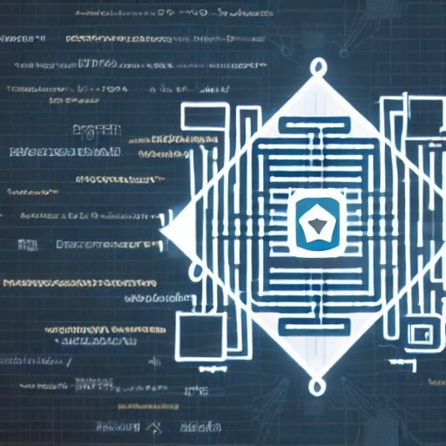

Decentralized oracles can use transparency and telemetry to gain insight into the inner workings and statistics of companies, helping to inform investment decisions in a technologically enhanced market. This information, such as financial performance, management team, and business strategy, can be used by investors and consumers to make more informed choices about investing in a particular company or product. In the future, trading bots may use this information to make automated investment decisions, potentially leading to increased demand for transparent companies and products that align with the preferences and ideologies of the network participants who control the value. This could create a feedback loop where transparent companies and products are more likely to be invested in, driving demand and affecting their value based on consumer preferences.

Blockchain-based voting is a revolutionary approach to governance that leverages the power of decentralized ledger technology to facilitate transparent, secure, and tamper-proof voting. The use of smart contracts and distributed consensus protocols ensures that the voting process is conducted in a fair and impartial manner, with all stakeholders having an equal say in the outcome or in relation to their stake in the network. Adaptive governance allows for the implementation of continuous and dynamic voting processes, enabling individuals and registered entities to actively participate in decision-making by casting votes on all issues that pertain to them, rather than being limited to a restricted number of opportunities to vote on specific issues annually. The benefits of immutability and transparency in blockchain-based voting are unparalleled. The use of cryptographic algorithms and decentralized consensus protocols ensures that the voting process is tamper-proof, and the results are unchangeable once they are recorded on the blockchain. This eliminates the risk of vote manipulation or fraud, and ensures that the outcome reflects the true will of the stakeholders.

The robustness of a technological adaptive governance system that uses these on-chain governance systems for voting is unmatched. The use of smart contracts and decentralized consensus protocols ensures that the voting process is efficient, secure, and transparent. The system is designed to adapt to the changing needs of its users, ensuring that the governance process is always responsive to the evolving needs of the community. This contrasts with the traditional voting systems that are ran by closed-source hardware and software, which could have backdoors or the ability to alter votes. In traditional voting machines, the software and hardware are controlled by a third party and could be vulnerable to manipulation or errors. This could lead to mistrust in the voting process and the outcome, making it more difficult to ensure the integrity of the voting process and the accuracy of the results. Overall, blockchain-based voting represents a significant step forward in the evolution of governance, offering a transparent, secure, and tamper-proof way of conducting elections and making decisions. The use of decentralized technology ensures that the voting process is fair, impartial, and efficient, fostering trust and participation among stakeholders. The adaptability and robustness of the technology ensures that the governance process is always responsive to the evolving needs of the community.

In a technological anarcho-capitalist society, the governance system and markets are designed to adapt to the needs of the community, which is made up of individuals who are also the users. This means that the community is empowered to make their own decisions about how they want to be governed and what type of economy they want to have, and the governance system and markets are responsive to the needs and preferences of the community members. The governance system and markets are designed to respond to the needs and preferences of the community members in a way that is similar to how computer programs are created to serve and implement the needs of the user. In this analogy, the community is the user and the governance and markets are the program, constantly adapting to the community's needs and preferences, providing a more decentralized and responsive system.

Non-Fungible Tokens or NFTs represent a revolutionary technology that utilizes blockchain to create unique, one-of-a-kind digital assets that cannot be replicated or replaced. The use of NFTs in the fine art, graphic arts and social media is just the beginning of the potential for this technology to enhance and transform society and various industries. NFTs offer a wide range of benefits, including tamper-proof ownership records, efficient transfer of ownership, and the ability to represent a wide range of assets in a digital format. This makes NFTs particularly useful in industries where ownership and provenance are important, such as real estate, finance, and collectibles. In the real estate industry, NFTs can be used to create digital representations of physical properties, allowing for the secure and efficient transfer of ownership. This can streamline the process of buying and selling properties, and also make it easier for individuals to prove ownership. In the finance industry, NFTs can be used to represent ownership of stocks, bonds, and other financial assets, providing a tamper-proof record of ownership and making it easier to trade and transfer these assets. This can increase the liquidity of these assets, making them more accessible to investors. In the collectibles industry, NFTs can be used to represent ownership of rare and unique items, such as trading cards, vintage cars, and other items. By creating digital representations of these items, NFTs make it easy for collectors to prove ownership and transfer ownership of these items, which can increase the value of these items. With regards to the gaming and digital content industry, NFTs allow the creators and owners of digital items to prove the authenticity and scarcity of their creations. In-game items or virtual items from virtual worlds can be turned into NFTs and can be bought, sold, and traded just like any physical item. This has created an entirely new economy around digital items.

NFTs can also be used in the music industry for representing ownership of rights to music and in the fashion industry for representing ownership of virtual clothing and accessories. In the identity management space, NFTs can be used as a form of digital identity, allowing individuals to prove their identity and ownership of assets in a secure and decentralized manner. Overall, NFTs have the potential to transform and enhance a wide range of industries, from real estate and finance to collectibles and gaming. The unique characteristics of NFTs make them ideal for representing ownership and provenance of assets, making it easier to buy, sell, and transfer these assets. The possibilities are endless and it will be interesting to see how NFTs continue to evolve and change the way the world thinks about ownership and digital assets.

Micropayments, enabled by blockchain and cryptocurrency, are small financial transactions that are typically issued in a frequent manner. The ability to perform micropayments creates payment streams in a more efficient and cost-effective way than traditional methods has the potential to change the way society is structured and optimize industries such as software and digital architecture as a service. With micropayments, individuals and businesses can be paid by the day, by the hour, or even by the minute or second for their services. This opens up new possibilities for how people can earn money and conduct business, such as through online content creation, streaming services, and other forms of digital work. Additionally, micropayments allow for the creation of an informational layer that can provide valuable data on stock-to-flow ratios and other market dynamics, such as how employers are paying their employees and the reliability of their payment streams. This can help individuals and businesses make more informed decisions about the companies they choose to work for.

In the software and digital architecture as a service industry, micropayments can change the way digital components are deployed and deconstructed. With micropayments, software and digital architecture can be broken down into smaller components and can be deployed or deconstructed quickly and more autonomously. This will enable businesses and individuals to easily access and use specific digital components that they need for their projects and use them on a pay-per-use basis.

Education is another field with the massive potential for complete transformation. Centralized education systems, such as state or federal general education systems, suffer from weaknesses that are inherent in centralized systems, such as being centrally planned and orchestrated with a focus on the needs and desires of the state or nation, rather than the well-being or intelligence of the students participating in the systems. These systems also have a tendency to push ideals and propaganda in order to benefit the central government by shaping the way children think from a young age.

Censorship resistance in education refers to the ability of individuals to access information and resources without interference or restriction from a centralized authority. This allows for a diverse range of perspectives to be presented, fostering critical thinking and the ability for individuals to form their own opinions. Non-biased approaches to education involve presenting information in an impartial manner, without the influence of personal or political biases. This ensures that individuals are exposed to a wide range of viewpoints, allowing them to make informed decisions based on a variety of perspectives.

“Let me control the textbooks, and I will control the state.” this eloquently stated quote by one of histories infamous totalitarian despots exemplifies the notion to transition to a more decentralized and opensource education model worldwide. Both censorship resistance and non-biased approaches to education have the benefit of promoting freedom of thought and expression, as well as encouraging individuals to seek out and evaluate multiple sources of information. This can lead to a more informed and engaged populace, as well as a more democratized society. Additionally, by providing access to diverse perspectives, censorship resistance and non-biased approaches to education can help to reduce extremism and promote social cohesion.

One of the main advantages of decentralized education systems, such as technologically enhanced homeschooling, is that they offer a more robust and efficient education. The internet and educational web applications provide access to a vast amount of information and resources, allowing for more personalized and selective social infrastructure for learning. Online accreditation and interactive education systems have the potential to increase the world's intelligence by providing access to a wide range of information and resources. In decentralized education systems, such as homeschooling or pod-based digital education systems, the amount of information available is vast and limited only by the expanding limits of the internet itself.

The internet, through worldwide inter-connectivity, offers a vast database of human knowledge that can be organized into optimized digital curriculums, offering multimedia and virtual reality experiences for students to collaborate on the most advanced platforms. This approach allows parents to have a greater degree of influence in shaping and actively engaging in the educational development of their children, while also providing more freedom in organizing and synchronizing the lesson schedule in a more cohesive and integrated manner. Parent driven curriculums also allow students to have a more personalized and selective and intentional social infrastructure for learning. Furthermore, it is free from government or state-driven censorship, biases, and propaganda that can often be found in centralized education systems. Instead, a decentralized education systems allow for a more open-source education standard that can be constantly updated, improved and curated by the community of educators and experts, rather than being restricted by government policies and regulations. This allows for a robust and unbiased education that equips students with the knowledge and skills to make their own informed decisions, rather than being conditioned to think a certain way.

Another important aspect of decentralized education systems is the ability to provide standardization in testing and accreditation. This would ensure that students are held to a consistent standard of knowledge and skills, regardless of their location or the specific education system they are using. This would also make it easier for students to transfer their education and skills to different contexts, whether it is within their own country or internationally. Decentralized education systems offer a wide range of benefits, from more interactive and engaging learning experiences unhindered by government bureaucracy, to a more unbiased and open-source education standard. The use of technology and the internet allows for greater collaboration, communication, and access to information for students, regardless of their location. It also allows for a more personalized and efficient education that is tailored to the specific needs and interests of the students, as well as providing a censorship-free and state-driven propaganda free education.

As advancements in technology and social structure continue to evolve and converge, it is crucial for communities to stay informed about the available options and alternatives in order to make informed and objective decisions. By staying ahead of the curve and understanding the potential implications of these emerging innovations, society has the opportunity to shape the future in a positive and impactful manner. The incorporation of these technologies and innovative methodologies is catalyzing a transformative shift towards a harmonious and equitable society, with a particular emphasis on revolutionizing public infrastructure. These disruptive advancements are poised to have a profound impact on re-shaping the world. A civilization's trajectory towards a sustainable and equitable future is contingent upon its ability to harness the power of its technological, methodological and lifestyle advancements in a synergistic manner. When a civilization operates in a short-sighted and unsustainable fashion, it can lead to detrimental effects on society and the environment. However, when a civilization embraces a long-term perspective, prioritizes sustainability, and cultivates a collective will to effect positive change, it has the potential to transcend its current state and achieve a transformative alchemical transmutation towards a golden age of prosperity, harmony and freedom.

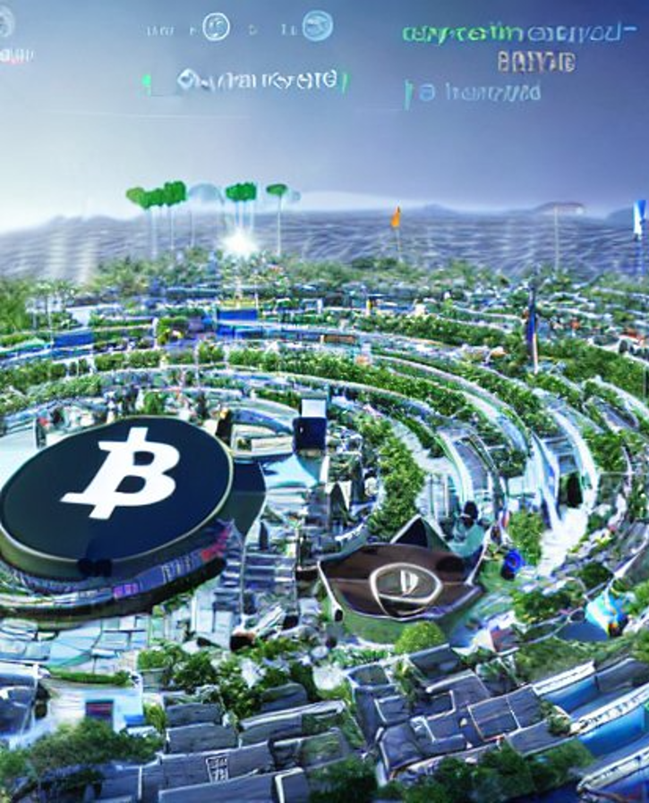

5: UNCENSORED

In the digital age, access to information is critical for the well-being and advancement of societies, markets, and industries. As such, it's important to have systems in place that ensure that the information provided is accurate, trustworthy, and not subject to censorship. This is why censorship resistance is the most fundamental and important reason why peer-to-peer and decentralized methodologies are emphasized and encouraged in today's technology landscape.

Decentralized systems provide a platform where information is shared between peers, allowing for a more equal distribution of knowledge and removing the need for a central authority to control and verify the information. This leads to a more democratic system where individuals can make informed decisions based on a variety of perspectives, rather than a single, often biased, source of information. By removing the middleman, decentralized systems promote transparency and accountability, making it difficult for any one entity to manipulate or control the flow of information. Additionally, censorship resistance promotes innovation and creativity.

With no central authority controlling access to information, individuals and organizations are free to experiment and explore new ideas. This results in a more vibrant and diverse technological ecosystem where individuals are able to make an impact in their own unique way. By promoting censorship resistance, the world can create a more equitable and just future where individuals have the freedom to express their ideas, share information, and collaborate with others without fear of repression or censorship.

The biased propagation of information can have devastating effects on societies, industries, and markets. By presenting only one perspective or a skewed version of events, individuals are making decisions based on incorrect and incomplete information. This creates a distorted reality, leading to harmful outcomes for communities and nations. For example, a government that censors information related to a public health crisis may inadvertently spread false information that leads to further harm, or a corporation that censors information about its products or practices may perpetuate harmful practices that hurt consumers and the environment. Moreover, censorship is a threat to individual liberty and freedom. When individuals are not able to access information, they are not able to make informed decisions and are at the mercy of those who control the information they receive. This can lead to a lack of trust in government and corporations, as well as a sense of powerlessness among the general population. In order to prevent these harmful outcomes, it's critical that individuals have access to all sides of an issue and all relevant information so that they can make informed decisions.

The importance of unbiased information becomes even more pronounced in the age of artificial intelligence (AI) and machine learning. AI is increasingly being used to inform important decisions, from medical diagnoses to the development of public policy. If the AI is trained on biased data, it will make decisions that are equally biased. This could result in harmful outcomes for individuals and society as a whole. To ensure that AI is making ethical and unbiased decisions, it's essential that the data it is trained on is not censored and represents all relevant perspectives.

Censorship resistant technologies and methodologies offer a unique set of benefits that can contribute to the stability, security and integrity of our technological systems. Firstly, censorship resistant systems are decentralized, meaning that there is no single authority controlling the flow of information. This makes it much more difficult for any one party to manipulate or censor information, as there are multiple sources of information available to any user. This, in turn, creates a more open and transparent environment, where users can access and verify information from multiple sources. Censorship resistant technologies often use cryptography to protect the privacy and security of user data. For example, blockchain technology uses cryptographic algorithms to secure the transactions on its network, making it much more difficult for any third party to tamper with or censor information. This creates a secure and trustworthy environment for users, where they can be confident that their information is protected and that their transactions are conducted in a transparent and honest manner. This has far-reaching implications for society, as it creates an environment where users can express themselves freely, share their opinions and contribute to the global conversation.

The ability to express oneself freely is a cornerstone of a free and open society, and censorship resistant technologies play a key role in promoting this ideal. Decentralized applications are designed to create a censorship-resistant platform for their users. This is achieved by removing the central point of control and distributing the decision-making power across a network of users. This means that users have more control over their data, and are less reliant on any single authority or entity to provide them with information or services. The benefits of censorship resistance are many, including the creation of more freedom and liberty for users. For example, users can access and share information freely, without fear of censorship or reprisal. Additionally, decentralized applications can incentivize the sharing of valuable and useful information, by rewarding users who contribute to the network. For example, users can be incentivized to share accurate and helpful information with others, by earning cryptocurrency tokens in return.

Another benefit of censorship resistance is the de-incentivization of undesirable or harmful content. Decentralized applications can be designed to detect and remove harmful or inappropriate content, without relying on a central authority to make these decisions. This creates a safer and more responsible environment for users, where harmful or inappropriate content is quickly removed, without the need for intervention by an external authority. One of the key benefits of censorship resistance is the freedom and liberty it offers to users. Decentralized applications create censorship resistant platforms that are not controlled by any one entity or government. This allows for more open and free expression of ideas and information, leading to a more diverse and inclusive society. Censorship resistant platforms also allow for the incentivization of desirable content and the de-incentivization of undesirable content through the use of cryptocurrency tokens. This creates a positive feedback loop where the most valuable and impactful content is rewarded and encouraged, leading to a higher quality of information and ideas. Another benefit is increased transparency and trust.

In the realm of media, censorship resistance is a crucial factor in ensuring that communities have access to a diverse array of perspectives and sources, without the threat of censorship or manipulation. The rise of the internet has disrupted traditional media, but it has also created new challenges, such as the need for trusted sources of information in a decentralized environment. The rise of the internet has brought about a revolution in the media landscape, creating both opportunities and challenges. To overcome these challenges, we must embrace cutting-edge technology and innovative solutions. Decentralized networks, cryptographic protocols, and smart contract oracles present a powerful answer to the issue of censorship and information accuracy in a distributed environment. They allow us to create a self-governing system of information dissemination where data is collected, processed, and analyzed in a transparent, verifiable, and tamper-proof manner.

When information is not censored, manipulated, or controlled by any one group or entity, it is more likely to be accurate and trustworthy. This leads to a greater sense of community and collaboration, as people can rely on the information they receive to be unbiased and true. In financial markets, trust and transparency are key, with accurate and timely information dissemination vital for fair and efficient outcomes. This information's accuracy becomes even more significant when combined with automated decentralized oracles that act upon it.

Smart contract oracles play a vital role in ensuring the integrity of information by collecting and aggregating data from multiple sources, reducing the risk of human error and bias in interpretation. The automation of data analysis and processing minimizes the chance of manipulation and error. Blockchain technology provides an immutable ledger of information, safeguarding the accuracy and integrity of data in the system. When combined, these technologies enable the creation of a decentralized network of information dissemination that provides communities with access to accurate, reliable, and trustworthy information. Censorship resistance is a critical factor in securing the future of information and media, fostering a sense of community and collaboration by ensuring that information is accurate, unbiased, and trustworthy. By leveraging cutting-edge technologies, we can create a decentralized network of information dissemination that empowers communities with access to transparent, verifiable, and tamper-proof information.

A distributed and interoperable current event information stream is a network of decentralized applications and smart contract oracles that gather and present real-time information about current events to users. The goal of this system is to create a trustless, decentralized source of information that is transparent, accurate, and unbiased. To accomplish this, the system leverages the power of decentralized web applications and smart contract oracles. The oracles act as intermediaries, gathering information from information dissemination nodes and verifying the authenticity and accuracy of the data. The oracles then present the information to users through a user interface, such as a mobile application or a website.

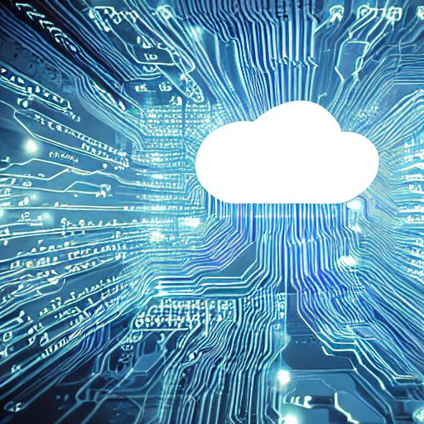

The information dissemination nodes are responsible for producing and distributing information about current events. These nodes are incentivized to provide accurate and unbiased information, as nodes that produce false or un-vetted information will have a lower score and may be punished by having their stake of governance tokens in the network slashed or destroyed. This provides a powerful incentive for nodes to produce reliable and trustworthy information. For example, consider a network that provides real-time information about natural disasters. The information dissemination nodes could be sources such as weather stations, satellite imagery, and news outlets. The oracles in the network would then verify the authenticity and accuracy of the information and present it to users through a mobile application. Users could then access real-time information about natural disasters, such as the location, intensity, and expected impact of a storm.

The creation of a distributed and interoperable current event information stream represents a step towards a more transparent, accurate, and trustworthy source of information. By leveraging the power of decentralized web applications and smart contract oracles, the system incentivizes truth and destroys biased and fake news producers, creating a truly trustless source of information for all users.

Censorship resistance is also crucial for the fair and just operation of machine learning and AI technologies. If these technologies are going to play an integral role in our future governance systems, it is imperative that they are trained with uncensored information and have access to all sides of all issues and concepts. This ensures that the AI is operating in a balanced and unbiased manner, making decisions that are in the best interests of society as a whole. The importance of censorship resistance in machine learning and AI cannot be overstated, as these technologies will shape the future in profound ways. Ensuring they are trained with unbiased information and have access to the truth is key to creating a future with integrity and in the best interests of the people. This is a vision of a future where everyone has access to the unbiased truth of the world around them. In this future, markets, societies, industries, and governance systems operate with integrity and are aligned with the best interests of the people. Decentralized technology, blockchain, machine learning, and AI, all come together to support this future. The importance of censorship resistance in all of these technologies is key to ensuring that information is not censored, manipulated, or controlled by any one group or entity.

Centralized governments often exert a strong influence over the flow of information that reaches the public. This control can take the form of censorship, where certain pieces of information are suppressed or altered, and propaganda, where information is deliberately crafted to promote a particular viewpoint or ideology. Both of these techniques are used to manipulate public perception and maintain the status quo.

To achieve this level of control over information, centralized governments control a centralized media infrastructure and often have centralized intelligence organizations that operate in secrecy. These organizations are tasked with gathering, analyzing, and disseminating information, and they often have the power to suppress information that could challenge the status quo or fundamentally alter society's understanding of reality. This type of information suppression can take many forms, such as censorship of news media, restrictions on access to government records, and the classification of sensitive information. In addition to censorship and propaganda, centralized governments have been known to conduct experiments on their citizens under the guise of environmental preservation or management. For example, some governments have been accused of manipulating weather conditions for military or geopolitical purposes. While the exact extent of these activities remains unclear, it is widely believed that such experiments pose a significant threat to the health and well-being of citizens and to the natural environment.

Overall, the use of censorship and propaganda by centralized governments can have far-reaching and harmful consequences. It undermines the free flow of information and stifles critical thinking, making it more difficult for people to make informed decisions and engage in constructive dialogue. The suppression of information and manipulation of reality by centralized intelligence organizations also threatens to erode the trust that is essential for democratic societies to function. Governments currently hold immense power, including the ability to abduct, detain indefinitely, and even murder its own citizens under various national security acts. These actions, though they may be deemed necessary by the governing systems, should not be taken without the consent and decision of the people they impact. A democratic process, where the community is able to be aware of, weigh in on and determine the appropriate course of action, is vital in ensuring transparency and accountability. Even in cases where such actions may be necessary for national security, it is imperative that they are taken through a democratic process that is guided by the values of transparency, accountability, and respect for citizens' rights and freedoms.

Decentralized and transparent governance systems, where information is freely accessible, can help to mitigate the potential for abuse of power. Ultimately, a healthy governance system is one in which the people have a say in all the actions taken by those who represent the various elected positions. The concealment of government activities, current and historical events, geological and geographical features, and potentially groundbreaking discoveries or solutions, perpetuates the lack of transparency and accountability. This suppression of information can lead to the concealment of knowledge that has the potential to transform the world.

The benefits of having access to unbiased journalism and up to date information about the world cannot be overstated. When people have access to accurate information, they are better equipped to make informed decisions. This leads to more productive, efficient, and fair outcomes in all areas of life, from personal finances to global politics. The more transparent and unbiased the information that people have access to, the more likely they are to make decisions that are in their best interests and the best interests of society as a whole.

7: THE BRIDGE

The world is always changing and evolving, and to get from where we are today to a better future state, we need to take coordinated and persistent steps. One such step is the adoption of partial solutions and compromises, which will allow the world to gradually embrace changes that ultimately guide us to a more optimal state. Decentralization and blockchain technology, for example, are spreading like an adaptive crypto virus that seeks to bring integrity to networks and financial applications and governance, while also having no single point of failure and being unstoppable by any entity. This concept of decentralization is already emerging in various industries, such as finance, real estate, and gaming, and is bringing numerous benefits to these sectors.

Centralization and decentralization differ significantly from a software perspective. Centralized systems often offer more robust application layers and can perform fast operations and store more data by leveraging centralized databases, while decentralized systems provide greater transparency and censorship resistance.

To better understand the relationship between centralization and decentralization, it's helpful to think of them as two sides of the same coin. An example of this interplay can be seen in the cryptocurrency exchange industry. Centralized exchanges (CEX) offer fast and sophisticated trading platforms, but they also have a single point of control and authority. On the other hand, decentralized exchanges (DEX) offer a more transparent and anonymous trading environment, but they can be vulnerable to smart-contract vulnerabilities and don't offer the same level of trading features as CEX or the ability to exchange for fiat, precious metals or securities.

At present, both CEX and DEX can operate synergistically, with CEX serving as an on-ramp for fiat currencies into the cryptocurrency space, and DEX providing a more transparent and decentralized environment for trading. Defi and fintech are also rapidly evolving, and there is a growing recognition of the need for a compromise between the two. In much the same way that a hybrid electric-gas car offers the benefits of both electric and gas power, the financial ecosystem of the future may contain elements of both centralization and decentralization.

One of the most significant developments in recent years has been the rise of decentralized stablecoins and the growing recognition of the benefits of using cryptocurrencies, such as Bitcoin, as legal tender. Decentralized stablecoins offer numerous benefits over centralized CBDCs, including greater transparency, immutability, and censorship resistance. The use of Bitcoin as the world reserve currency would create a more resilient hybrid central-decentralized governance system that would be less susceptible to government manipulation and control.

Another area where decentralization is having a major impact is in the digitization of government services. By allowing citizens to use SSI and DID as proof of identity, in addition to state-issued digital IDs, governments can improve accountability, transparency, and accessibility while also enhancing the privacy and self-sovereignty of their citizens.

Decentralized notary services have the potential to disrupt the current way that things are done, offering a more sophisticated and reliable approach to document verification and authentication. If implemented on a large scale, a decentralized notary system could bring greater transparency, security, and reliability to numerous industries, such as real estate, finance, and logistics.

In a decentralized world, it's essential to protect digital property, as anything can be copied and shared for free instantaneously. This is where non-fungible tokens (NFTs) and other cryptographic hashing techniques come into play, as they allow artists and authors to programmatically attach metadata and encrypted information to their digital creations, establishing proof of ownership and uniqueness. This not only helps to protect the creators' intellectual property rights, but it also allows for the buying and selling of digital goods in a secure manner.

Additionally, NFTs are revolutionizing the way that art and collectibles are bought and sold. In the past, the authenticity of a piece of art or a collectible was determined by physical attributes such as signatures, stamps, and certificates of authenticity. However, with the rise of digital art and collectibles, NFTs are providing a new way for artists and collectors to verify the authenticity of digital items, as each NFT is unique and cannot be duplicated. This has led to a growing market for NFT-based collectibles and digital art, with some pieces fetching millions of dollars in recent sales.

The use of NFTs and other cryptographic techniques also has implications for the gaming industry, where virtual items and in-game currency can now be bought, sold, and traded as NFTs, providing players with real ownership of their virtual goods. This is a significant shift from the traditional model where virtual goods were simply licensed to players, who had no real ownership or control over them.

The use of NFTs and other cryptographic techniques for protecting digital property is rapidly gaining traction, providing new opportunities for artists, collectors, and gamers to own and control their digital creations. As the digital world continues to grow, it's likely that the use of NFTs and other cryptographic techniques will become increasingly important for protecting digital property and establishing proof of ownership and uniqueness.  
  
Creative Commons, Copyleft, and GPL are just a few examples of strong licenses that aim to promote the sharing of intellectual property in a decentralized world. These licenses allow for, and sometimes demand, specific freedoms when it comes to works of art, writings, software, and other creative works. The basic idea behind these licenses is to encourage the evolution of creativity and the sharing of information by giving people the freedom to use, modify, and distribute works, as long as they meet certain conditions and follow certain rules. This approach can lead to a future of sophisticated technologies and advancements in all areas of life, through a renaissance of re-structuring the way intellectual property is conveyed.

Just like with any industry or technology, there is a need for a balanced approach when it comes to new infrastructures, such as the use of cryptographic hashing techniques and NFTs. By having open and equitable communities, the possibilities for advancing technology and creativity become endless. For instance, communities can take an opensource approach in the planning of these projects, ensuring efficiency and fairness in the distribution and sharing of intellectual property. This approach, in turn, can lead to the development of new and innovative solutions, benefiting everyone involved in the creation, distribution, and use of intellectual property.



7: THE OLD CODE

Insert chapter seven text here. Insert chapter seven text here. Insert chapter seven text here. Insert chapInsert chapter six text here. Insert chapter six text here. Insert chapter six text here. Insert chapter six text here. Insert chapter six text here. Insert chapter six text here. Insert chapter six text here. Insert chapter six text here. Insert chapter six text here. Insert chapter six text here. Insert chapter six text here. Insert chapter six text here.

Insert chapter six text here. Insert chapter six text here. Insert chapter six text here. Insert chapter six text here. Insert chapter six text here. Insert chapter six text here. Insert chapter six text here. Insert chapter six text here. Insert chapter six text here. Insert chapter six text here. Insert chapter six text here. Insert chapter six text here. Insert chapter six text here. Insert chapter six text here. Insert chapter six text here. Insert chapter six text here. Insert chapter six text here. Insert chapter six text here. Insert chapter six text here. Insert chapter six text here. Insert chapter six text here. Insert chapter six text here. Insert chapter six text here. Insert chapter six text here. Insert chapter six text here. Insert chapter six text here. Insert chapter six text here. Insert chapter six text here. Insert chapter six text here. Insert chapter six text here. Insert chapter six text here. Insert chapter six text here. Insert chapter six text here. Insert chapter six text here. Insert chapter six text here. Insert chapter six text here.

Insert chapter six text here. Insert chapter six text here. Insert chapter six text here. Insert chapter six text here. Insert chapter six text here. Insert chapter six text here. Insert chapter six text here. Insert chapter six text here. Insert chapter six text here. Insert chapter six text here. Insert chapter six text here. Insert chapter six text here. Insert chapter six text here. Insert chapter six text here. Insert chapter six text here. Insert chapter six text here. Insert chapter six text here. Insert chapter six text here. Insert chapter six text here. Insert chapter six text here. Insert chapter six text here. Insert chapter six text here. Insert chapter six text here. Insert chapter six text here. Insert chapter six text here. Insert chapter six text here. Insert chapter six text here. Insert chapter six text here. Insert chapter six text here. Insert chapter six text here. Insert chapter six text here. Insert chapter six text here. Insert chapter six text here. Insert chapter six text here. Insert chapter six text here. Insert chapter six text here.

Insert chapter six text here. Insert chapter six text here. Insert chapter six text here. Insert chapter six text here. Insert chapter six text here. Insert chapter six text here. Insert chapter six text here. Insert chapter six text here. Insert chapter six text here. Insert chapter six text here. Insert chapter six text here. Insert chapter six text here. Insert chapter six text here. Insert chapter six text here. Insert chapter six text here. Insert chapter six text here. Insert chapter six text here. Insert chapter six text here. Insert chapter six text here. Insert chapter six text here. Insert chapter six text here. Insert chapter six text here. Insert chapter six text here. Insert chapter six text here. Insert chapter six text here. Insert chapter six text here. Insert chapter six text here. Insert chapter six text here. Insert chapter six text here. Insert chapter six text here. Insert chapter six text here. Insert chapter six text here. Insert chapter six text here. Insert chapter six text here. Insert chapter six text here. Insert chapter six text here.



Insert chapter six text here. Insert chapter six text here. Insert chapter six text here. Insert chapter six text here. Insert chapter six text here. Insert chapter six text here. Insert chapter six text here. Insert chapter six text here. Insert chapter six text here. Insert chapter six text here. Insert chapter six text here. Insert chapter six text here. Insert chapter six text here. Insert chapter six text here. Insert chapter six text here. Insert chapter six text here. Insert chapter six text here. Insert chapter six text here. Insert chapter six text here. Insert chapter six text here. Insert chapter six text here. Insert chapter six text here. Insert chapter six text here. Insert chapter six text here. Insert chapter six text here. Insert chapter six text here. Insert chapter six text here. Insert chapter six text here. Insert chapter six text here. Insert chapter six text here. Insert chapter six text here. Insert chapter six text here. Insert chapter six text here. Insert chapter six text here. Insert chapter six text here. Insert chapter six text here.

Insert chapter six text here. Insert chapter six text here. Insert chapter six text here. Insert chapter six text here. Insert chapter six text here. Insert chapter six text here. Insert chapter six text here. Insert chapter six text here. Insert chapter six text here. Insert chapter six text here. Insert chapter six text here. Insert chapter six text here. Insert chapter six text here. Insert chapter six text here. Insert chapter six text here. Insert chapter six text here. Insert chapter six text here. Insert chapter six text here. Insert chapter six text here. Insert chapter six text here. Insert chapter six text here. Insert chapter six text here. Insert chapter six text here. Insert chapter six text here. Insert chapter six text here. Insert chapter six text here. Insert chapter six text here. Insert chapter six text here. Insert chapter six text here. Insert chapter six text here. Insert chapter six text here. Insert chapter six text here. Insert chapter six text here. Insert chapter six text here. Insert chapter six text here. Insert chapter six text here.

Insert chapter six text here. Insert chapter six text here. Insert chapter six text here. Insert chapter six text here. Insert chapter six text here. Insert chapter six text here. Insert chapter six text here. Insert chapter six text here. Insert chapter six text here. Insert chapter six text here. Insert chapter six text here. Insert chapter six text here. Insert chapter six text here. Insert chapter six text here. Insert chapter six text here. Insert chapter six text here. Insert chapter six text here. Insert chapter six text here. Insert chapter six text here. Insert chapter six text here. Insert chapter six text here. Insert chapter six text here. Insert chapter six text here. Insert chapter six text here. Insert chapter six text here. Insert chapter six text here. Insert chapter six text here. Insert chapter six text here. Insert chapter six text here. Insert chapter six text here. Insert chapter six text here. Insert chapter six text here. Insert chapter six text here. Insert chapter six text here. Insert chapter six text here. Insert chapter six text here.

